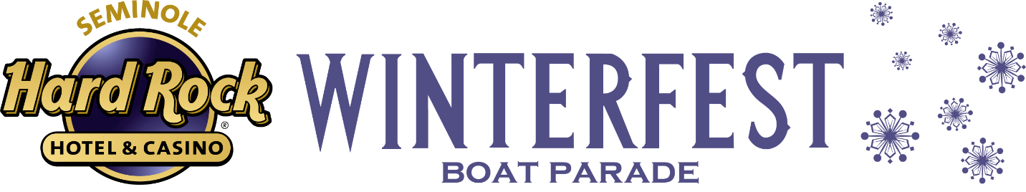
**Media Alert**
FOR IMMEDIATE RELEASE
Seminole Hard Rock Winterfest Boat Parade Announced as Grand Finale of Fort Lauderdale’s America 250 Celebration

Broward County, Fort Lauderdale, Florida – May 15, 2026 — May 15, 2026) — Winterfest is proud to announce that the Seminole Hard Rock Winterfest Boat Parade will serve as the official grand finale of the City of Fort Lauderdale’s America 250 Celebration, a yearlong tribute commemorating the 250th Anniversary of the United States.
Bringing together community, culture, and coastal tradition, Winterfest’s iconic Boat Parade will cap off a series of patriotic events hosted throughout the year, celebrating the spirit, history, and vibrancy of America—right here along Greater Fort Lauderdale’s world-famous waterways.
“Winterfest is honored to be part of this historic milestone,” said Lisa Scott-Founds, President and CEO, Winterfest, Inc. “As the ‘Best Show on H2O,’ the Parade is a perfect reflection of our community’s pride, creativity, and love for celebrating America in a uniquely South Florida way in Broward County.” Mayor Dean Trantalis added, “The Seminole Hard Rock Winterfest Boat Parade is always one of our city's most iconic annual events, bringing the joy of the holidays to life on the city's waterways. This year's event will be even more special as it caps the yearlong celebration of the nation's 250th anniversary. I look forward to one of the most spectacular Boat Parades ever.”
America 250 Celebration Highlights
The City of Fort Lauderdale’s America 250 Celebration will feature a dynamic lineup of events leading up to the Winterfest Boat Parade finale, including:
- American Beach Bash – Saturday, May 23, 2026
A lively kickoff event celebrating sun, sand, and American spirit with live entertainment, family-friendly activities, and beachfront festivities. Click Here
- Memorial Day Observance – Monday, May 25, 2026
A meaningful tribute honoring the brave men and women who gave their lives in service to the nation, featuring ceremonial elements and community reflection. Click Here
- 4th of July Spectacular – Saturday, July 4, 2026
A star-spangled celebration with live music, food, and one of South Florida’s most dazzling fireworks displays lighting up the night sky. Click Here
- Grand Finale – Seminole Hard Rock Winterfest Boat Parade
“Party in the U.S.A” Parade Theme – Saturday, December 12, 2026
The Seminole Hard Rock Winterfest Boat Parade will bring the celebration to a spectacular close, featuring elaborately decorated boats, celebrity appearances, salute to the military, and 12-miles of spectators lining the New River and Intracoastal Waterway. This year’s Parade will incorporate patriotic elements in honor of America250, making it an unforgettable finale to a landmark year as the organization also honors the Parade’s 55th Anniversary.
For more information on event schedules, participation opportunities, and sponsorships, please visit Winterfestparade.com or call 954.767.0686.
To view AI Generated images of possible themes and decorations for this year’s Parade CLICK HERE

###

About Winterfest®, Inc.

Winterfest® is a Florida not-for-profit organization based in Broward County that produces a variety of events including the free public event known as the Seminole Hard Rock Winterfest® Boat Parade - "The World’s Most Watched Boat Parade." Approximately one million spectators view the Parade on the 12-mile route along with millions more via television and the internet bringing National and International recognition to South Florida. Winterfest® also hosts annual events to enhance the community’s image and provide unique, wholesome family entertainment. For more information on Winterfest® please contact the office at (954) 767-0686 or their website: www.winterfestparade.com.

About Seminole Hard Rock Hotel & Casino Hollywood
Seminole Hard Rock Hotel & Casino Hollywood is the flagship-integrated resort of Hard Rock International, owned by the Seminole Tribe of Florida. The renowned entertainment, gaming and hospitality destination unveiled a $1.5 billion expansion in 2019, highlighting the debut of the world’s first and only Guitar Hotel. Between three hotel towers, the resort boasts 1,271 luxury guestrooms. Amenities include a 42,000 square-foot Rock Spa® & Salon; an 18-acre recreational water experience; private “Bora Bora” style cabanas; more than 20 food and beverage outlets; a 26,000 square-foot retail promenade; 120,000 square feet of premier meeting and convention space; and an expansive gaming floor with more than 2,500 slots, more than 200 table games and a 45-table poker room. In 2023, the casino launched live craps, roulette and retail sports betting, offering 10 craps tables, 20 roulette tables, and sports betting locations including both electronic kiosks and kiosks with live sports betting agents. Introducing the new games is a historic milestone that immediately puts Florida in the same league as the world’s great gaming destinations. Hard Rock Live, ranked No. 4 worldwide in 2024 gross revenue for Pollstar Magazine, highlights A-list entertainers and performers, sporting events and live broadcast productions in an intimate 7,000-person capacity setting. Seminole Hard Rock Hollywood is located on 87 acres of the Hollywood Seminole Reservation along State Road 7 (U.S. Highway 441). For more information, visit us online at www.seminolehardrockhollywood.com call 1 (800) 937-0010 or follow us: Facebook: @HardRockHolly, X: @HardRockHolly, Instagram: @HardRockHolly.

