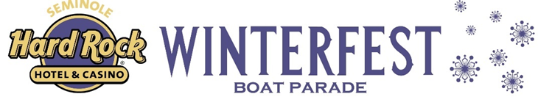
NEWS RELEASE
FOR MORE INFORMATION:
Kathy Keleher, Winterfest®, Inc.
954-767-0686, kathy@winterfestparade.com
Website: winterfestparade.com
FB: winterfest.parade
Twitter/Instagram: WinterfestInc
#WinterfestFL

FOR IMMEDIATE RELEASE
Seminole Hard Rock Winterfest Boat Parade Cancelled for December 16, 2023
Fort Lauderdale, Florida l Friday, December 15, 2023 - The Seminole Hard Rock Winterfest Boat Parade, scheduled for Saturday, December 16, 2023, has regretfully been canceled due to unprecedented weather conditions that includes heavy winds and unsafe boating conditions. The decision to cancel the event was made under the guidance and advisement of the United States Coast Guard, Fort Lauderdale Marine Patrol, Fort Lauderdale Fire Department, and other relevant agencies.
The safety and well-being of our participants, and spectators are of utmost importance to us. The inclement weather conditions, which are beyond our control, make it impossible to ensure a safe and enjoyable experience for everyone involved.
We understand the disappointment this may cause and apologize for any inconvenience. We appreciate the support and understanding of all those who were looking forward to the Seminole Hard Rock Winterfest Boat Parade.
While this year's parade had promising plans and breathtaking decorations from the boaters, our focus is already on next year's event, aiming to surpass expectations. Drawing attendees from across the globe, The Seminole Hard Rock Winterfest Boat Parade stands as a beloved highlight and cherished gem of South Florida, and our commitment remains steadfast in offering a year-round calendar of events and entertainment that captivates audiences worldwide. In fact, the Grand Marshal Reception featuring Boyz II Men is scheduled for 7:00 PM tonight and will feature the anthem for Broward County by Alexander Star + The Golden People “Laudy Dayo” which was scheduled to be performed on the Visit Lauderdale showboat.
WSVN will produce and air a television special featuring all our 2023 events which includes boats that have already decorated for this year and previous parades on Friday, December 22, 2023, at 7:00 PM. The show will also air on WSVN Channel 7 on December 25, 2023, and January 1, 2024, with additional dates scheduled on Bally Sports Sun. Their sister station will air in Boston on December 25 on WHDH (7 News) and December 31 on WLVI (CW56). We also proudly drive engaging initiatives like our student art contest. We remain committed to providing a memorable and enjoyable experience for our community and will continue our unwavering dedication to marine safety and projects that support our veterans.
The scope of the Seminole Hard Rock Winterfest Boat Parade has many moving parts hence the difficulty to reschedule. The magnitude of planning is immense, including permitting, and coordination with multiple agencies to manage bridges being locked up, docks vacated for staging and other logistics for overall safety. It took us months to orchestrate this event and all its moving pieces. This event is not a simple one to pivot and effectively plan safely within a few days.

For further information and updates, please visit our website Winterfestparade.com or contact 954.767.0686.
###

