 Entry #___________ (For Office Use Only)

2018 PARADE APPLICATION PART 2 – DECORATION INFORMATION FORM

PLEASE DRAW YOUR LIGHTING/DECORATION PLAN ON THE IMAGE SIMILAR TO YOUR VESSEL SUPPLIED:
(rough sketch using or attach a photo/detailed drawing )

◻ PRIVATE ◻ NON-PROFIT ◻ COMMERCIAL ◻ TOUR-CHARTER ◻ NON-MOTORIZED

◻ SAIL ◻ BARGE ◻ OTHER ____________________________

VESSEL NAME: __________________________________________________ SIZE: ___________________

CAPTAIN’S NAME: _________________________________________________________________

PHONE:_________________________________

COORDINATOR NAME (person handling decorations): ________________________________________________

PHONE:_________________________________

Please write very brief/informative TELEVISION COMMENTARY on your boat entry (two / three lines):

________________________________________________________________________________________________

________________________________________________________________________________________________

________________________________________________________________________________________________

What SIGNAGE will be on your vessel? _______________________________________________________________

_________________________________________________________________________________________________

What is the “TITLE THEME” of your vessel? (This will be used in the television special and Boat Parade Program)

_________________________________________________________________________________________________

How did your vessel get her name? ___________________________________________________________________

When completing Application Part 2, please bear in mind that this part is specifically used for the television commentary of the Parade.

DECORATING:

Tell us all about your DECORATING PLANS and how the design relates to the parade’s theme “Best of the 80s” or Holidays (Please be specific):_________________________________________________________________

_________________________________________________________________________________________________

Who will be decorating your entry? (Family, friends, professional):________________________________________

When will your vessel be decorated? Date/Time: ________________________________________________________

Decorating Plans - LIGHTING, PROPS, FABRICS, and other MATERIALS used___________________________

_________________________________________________________________________________________________

COSTUMES: _____________________________________________________________________________________

_________________________________________________________________________________________________

SOUND DESCRIPTION (Music will be a strong element with this year’s theme)

What type of music will you have board? __________________________________________________________________________________________

Who will be broadcasting/performing the music to the spectators a DJ, Band or the Radio? ___________________

_________________________________________________________________________________________________

FAVORITE PARADE MEMORY (if you have been in the Parade before – what is your favorite memory):

_________________________________________________________________________________________________

THEME: In honor of this year’s theme, why did you pick this play?
Does this memory relate to your decorations? __________________________________________________________

_________________________________________________________________________________________________

REMINDER: Decorating is more than just strings of lights – use prefabricated lighted displays, painted structures, Costumes add excitement to the parade. . In order to enhance your boat’s opportunity for television and radio coverage, highlight your vessel with live visual entertainment, animated decorations, etc. When creating – look for movement in your decoration!

Application 1, Application 2 and Proof of Insurance MUST be received for final acceptance into the parade. Proof of Insurance and liability requirements are: Full Liability, property damage and personal injury insurance on their vessel. Proof of coverage in the form of a certificate of insurance will need to be submitted to our office with applications
Both Official Entry Applications must be filled out and returned to the Winterfest office by 5:00 p.m. DECEMBER 1, 2018. *PLEASE NOTE THAT ANY APPLICATIONS NOT RECEIVED BY THIS DEADLINE WILL NOT BE GUARANTEED COMMENTARY IN THE TELEVISION SPECIAL.

Applications received at the Captain’s Meeting on the December 10th will be accepted and forwarded – but television/radio commentary is NOT guaranteed.

Remember this information is used for the television commentary – be descriptive!!!!!

REMINDER: Please keep in mind that in the eyes of a child there is ONLY ONE SANTA CLAUS.

Only one boat will be allowed to host a live Santa Claus which is boat #100 - therefore, any vessel (other than the one designated by Winterfest) with a live Santa Claus or person with a Santa Hat and beard will NOT be permitted to participate the parade.

The Seminole Hard Rock Winterfest Boat Parade is a family oriented event which will be viewed by children and adults of all ages. Applicant is hereby notified that all decorations and entertainment must be wholesome and suitable for viewing by minors. Winterfest, Inc. Reserves the right to prevent any boat from participating in the parade that displays obscene decorations, nudity or profanity. By signing this application, applicant hereby acknowledges and consents to be bound by the above terms and conditions.

“STAR” OPPORTUNITY
Every year Winterfest is approached by celebrities, dignitaries and entertainers to be a part of the parade. Please let us know if you would like an opportunity to host a dignitary, entertainer or animated character during our parade.

Check one:

❒ Yes, please ask me
❒ No, not interested

If you have any questions regarding this application,
please feel free to contact the Winterfest
office (954)767-0686. We look forward to your participation.

__________________________________________________________
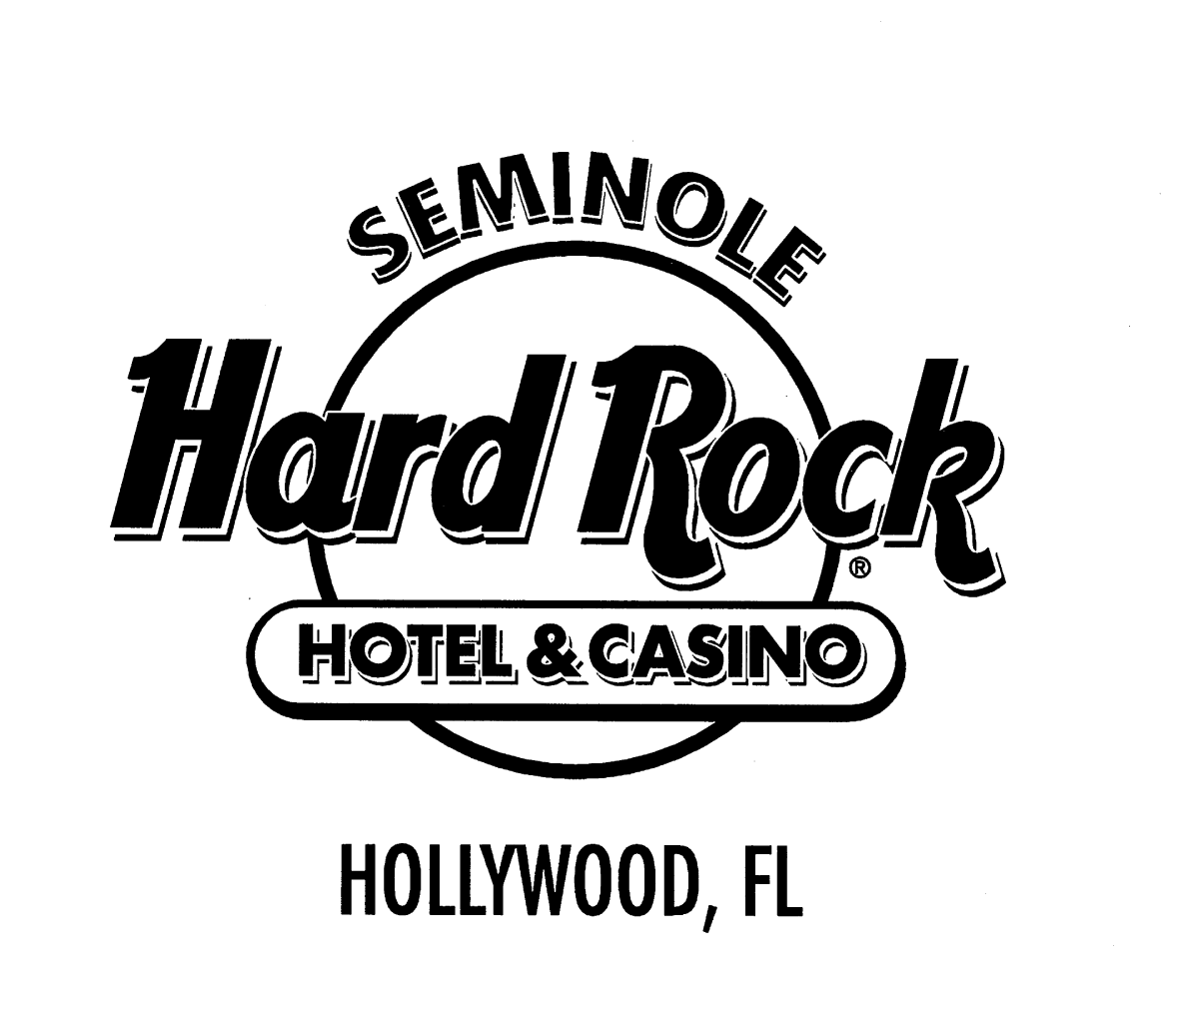
Entrant
REMEMBER: MANDATORY SKIPPER’S MEETING ON
MON., DEC. 10th at 6 p.m.
at the Hilton Marina 17th Street Causeway
No Applications will be taken at the CAPTAIN’S MEETING
without prior notification
This is part of the Application Process– no entry is granted by submission

Decorations may be subject to inspection by Winterfest
Contact: Kathy Keleher, Winterfest, Inc. * 512 Northeast 3rd Avenue * Ft. Lauderdale, Florida * 33301
(954) 767-0686 * fax: (954) 767-0665 * kathy@winterfestparade.com * www.winterfestparade.com

We thank you in advance for your cooperation.
Please remember to sign the Liability and Consent forms.

REMEMBER: submit with a copy of your insurance declaration page with your liability information.

By submission of this application – the captain and crew of this vessel have accepted the rules,
Release of liability, waivers of the Winterfest, Inc. and the City of Fort Lauderdale regarding the event and have submitted proof of insurance as requested.

