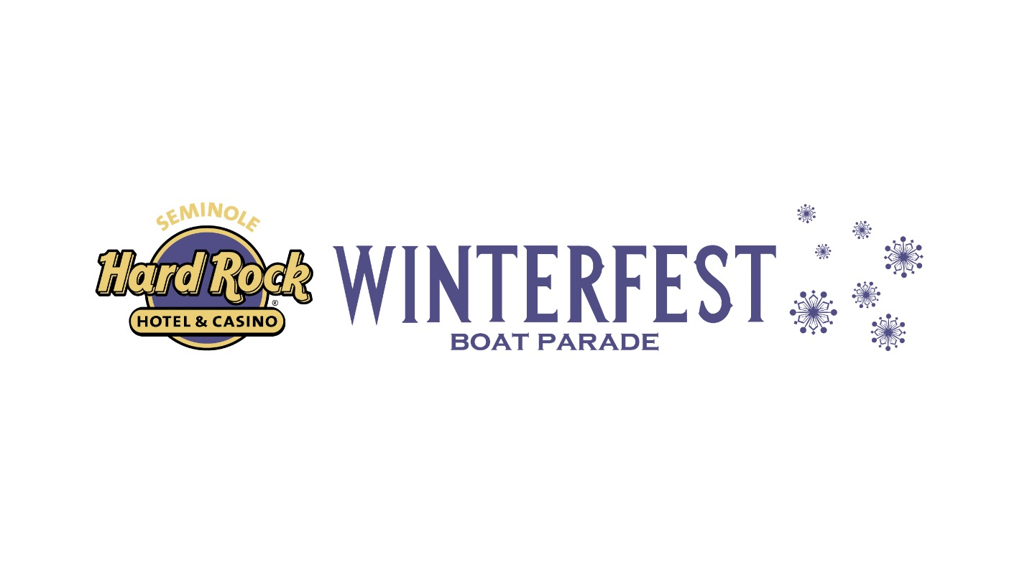

**NEWS RELEASE**

**FOR MORE INFORMATION:**

**Kathy Keleher,** Marketing and Parade Director, Winterfest, Inc., 954-767-0686,

[Kathy@winterfestparade.com](mailto:Kathy@winterfestparade.com) #WinterfestFL18

winterfest.parade @winterfestinc @winterfestinc @WinterfestParade101



**Sandra J. Rios,** Director of Public Relations, Seminole Hard Rock Hotel & Casino Hollywood, [sandra.rios@seminolehardrock.com](mailto:sandra.rios@seminolehardrock.com), 954-327-7504

seminolehardrockhollywood @HardRockHolly @HardRockHolly



**Charlotte Vermaak**, PR Manager, Broadway Across America, 954-626-7821, [Charlotte.Vermaak@BroadwayAcrossAmerica.com](mailto:Charlotte.Vermaak@BroadwayAcrossAmerica.com)

BroadwayAcrossAmerica @BwayAmerica @BAANational



**Seminole Hard Rock Winterfest® Boat Parade and Black Tie Ball Honored with The Broadway League’s**

**“Star of Touring Broadway Award”**

***Award recognizes Winterfest, Inc. for its outstanding efforts in promoting Broadway theater to the Greater Fort Lauderdale community.***

**Broward County, FL –** The glimmer of Broadway will be in South Florida on October 9,2018, as Susie Krajsa, president of Broadway Across America, presents Winterfest, Inc. with the Broadway League’s “Star of Touring Broadway Award”. The award honors board members, government officials, donors and volunteers who support and promote the Broadway Series, enriching their communities and hometowns.

Winterfest, Inc. was nominated for elevating the profile of Broadway in Fort Lauderdale and building excitement locally for upcoming engagements of hit Broadway shows. The Seminole Hard Rock Winterfest® Black Tie Ball, highlights Broadway performances within the event along with themed décor, table names, and Broadway-inspired fashion. In 2017, The Seminole Hard Rock Winterfest® Boat Parade ("Greatest Show on H2O") was themed “Broadway on Parade.” Private boats and mega yachts with decorations reflective of Broadway shows made their way along the 12 mile parade route where more than 1 million live viewers lined the waterways to watch, while over 9 million viewers watched the Winterfest TV special.

Representatives from Winterfest, Inc., Seminole Hard Rock Hotel & Casino Hollywood, government officials and community leaders will be on hand for the award presentation. Other representatives from Broadway Across America will be in attendance with Ms. Krajsa including performers from The Phantom of the Opera - Christine and Raoul. Media and Winterfest, Inc. supporters will also be invited to the presentation from 11:30 a.m. -12:30 p.m. Light refreshments will be served.

For more information about the Seminole Hard Rock Winterfest® Boat Parade or how to attend this year, please visit [winterfestparade.com](http://winterfestparade.com) or call [954-767-0686](tel:954-767-0686).

*# # #*

The Broadway League’s 2018 Spring Road Conference announced the complete list of winners. In addition to Winterfest, Inc., other Star of Touring Broadway Award recipients included:

* Alex Hauntypaints original works using acrylic on canvas that are then printed as

giclee’ prints, posters and cards. Alex donates a significant portion to his nonprofit Alex Haunty’s Theater and Arts Fund, Inc., to buy tickets for people with disabilities to see Broadway shows.

* Delta Dental of Michigan has supported Wharton Center for the Performing Arts’

Broadway season since 1986.

* Don Rodman,Founder and President of Rodman for Kids, an umbrella matching gift charity that raises funds for youth-focused social service organizations that support at-risk youth in Massachusetts.

Other honorees included:

* John Ballard, President of Magic Space Entertainment – Distinguished Lifetime Service Award
* John Ekeberg, Executive Director for the Broadway and Cabaret divisions at the

Denver Center for the Performing Arts (DCPA), the largest non-profit theatre organization in the nation, Samuel J. L’Hommedieu Award for Outstanding Achievement in Presenter Management

* Rosalee Roberts, Public Relations Director at Omaha Performing Arts in

Omaha, NE – Outstanding Achievement in Road Marketing & Press

* Tracy Butler, Director of Education at the Kravis Center for the Performing Arts

in West Palm Beach, FL – Outstanding Achievement in Education and Engagement

* Kathleen Maki, national Director of Corporate & Group Sales for Broadway Across

America, is a ten year theatrical Group Sales veteran – Outstanding Achievement in Road Group Sales

* Nancy McDaniel, Senior Operations Manager at Broadway Across America, the nation's leading presenter of touring Broadway, Southeast region – George MacPherson Road Award

*# # #*

***THE BROADWAY LEAGUE*** *(Charlotte St. Martin, President), founded in 1930, is the national trade association for the Broadway industry. The League’s 700-plus members include theatre owners and operators, producers, presenters, and general managers who present in nearly 200 markets in North America. Each year, League members bring Broadway to nearly 30 million people in New York and on tour across the U.S. and Canada. The Broadway League has recently added a new category for International membership to collaborate with professionals from around the world who produce and present Broadway quality theatre. The Broadway League annually co-presents the Antoinette Perry “Tony” Awards®, one of the most coveted awards in the entertainment industry. Key League programs and resources include: Kids’ Night on Broadway®, The Jimmy® Awards, Stars in the Alley®, Internet Broadway Database® (ibdb.com), Broadway.org, SpotlightonBroadway.com, Commercial Theater Institute (with Theatre Development Fund), as well as numerous conferences and forums for our members. Broadway Bridges™, with the support of the New York City Department of Education, is aimed at giving every New York City public high school student the opportunity to see a Broadway show before graduation. TheatreAccessNYC (co-produced with TDF) is the one-stop website of accessible Broadway performances for theatregoers with disabilities. Families.Broadway is the League’s site for family friendly offers and pricing. Broadway.org is the League’s official on-line headquarters for Broadway in NYC, on tour, and internationally. Broadway.org is the League’s official on-line headquarters for Broadway in NYC, on tour, and*

*internationally. For more information visit BroadwayLeague.com, or follow @BroadwayLeague on Twitter*

*and visit us at Facebook.com/BroadwayLeague. Broadway theatres are filled with an exciting array of new and classic musicals and plays, providing the perfect experience for every audience. Great seats are available at every price point and are easy to buy online, by phone, or in person at theatre box offices. It’s always the perfect time to see a show. Broadway performs every day of the week at multiple curtain times to accommodate every schedule.*

***About Winterfest, Inc.***

*Winterfest is a Florida not-for-profit organization based in Broward County that produces a variety of events including the free public event known as the Seminole Hard Rock Winterfest Boat Parade - "The World’s Most Watched Boat Parade." Approximately one million spectators view the Parade on the 12-mile route along with millions more via television and the internet bringing National and International recognition to South Florida. Winterfest also hosts annual events to enhance the community’s image and provide unique, wholesome family entertainment. For more information on Winterfest, please contact the office at (954) 767-0686 or their website:* *www.winterfestparade.com**.*

***About Seminole Hard Rock Hotel & Casino Hollywood***

*Seminole Hard Rock Hotel & Casino, South Florida’s most iconic entertainment, gaming and hospitality destination, is a AAA Four Diamond-rated resort with 461 luxury guest rooms and suites; award-winning restaurants; exciting nightlife; a lagoon-style pool and Beach Club Bar & Grill; a Rock Spa; and premium meeting and convention space. Top entertainers grace the stage at the Hard Rock Event Center and casino patrons enjoy more than 100 table games, 2,000 of the most popular slots and a 37-table poker room. Fine dining options include Council Oak Steaks & Seafood, the resort’s signature steakhouse, and Kuro, a luxe and socially vibrant restaurant offering new-style Japanese cuisine.   In the heart of the hotel is L Bar, a sophisticated, contemporary lounge showcasing handcrafted, classic cocktails with a twist. Contemporary and casual eateries include Blue Plate, the hotel’s 24-hour diner-inspired restaurant; Constant Grind, a gourmet coffee and pastry shop; and the ever-famous Hard Rock Cafe, Hollywood, part of Hard Rock’s 185 globally recognized rock ‘n’ roll restaurants.  A $1.5 billion expansion slated to open in fall, 2019, will bring 638 new guestrooms and suites to a landmark, guitar-shaped hotel; 168 rooms and suites to a new pool tower overlooking a lush, private cabana area; three extensive water features for relaxing, sunbathing, swimming and paddleboarding; 30 new restaurants and nightlife venues; a new 41,000 square-foot Rock Spa®; 3,000 new slot machines, 193 table games and a 46 table poker room;  a state-of-the-art, 6,500-seat Hard Rock Live concert arena; 21,000 square-feet of retail space; and 120,000 square-feet of premium meeting and convention space. For more information, call 800-937-0010, visit us at www.seminolehardrockhollywood.com, or follow us on:*

*Facebook: @SeminoleHardRockHollywood, Twitter: @HardRockHolly, Instagram: @HardRockHolly.*