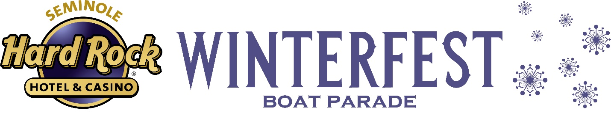
NEWS RELEASE

FOR MORE INFORMATION:
Kathy Keleher, Winterfest, Inc.
954-767-0686, kathy@winterfestparade.com
Website: winterfestparade.com
FB: winterfest.parade
Twitter: WinterfestInc

IMMEDIATE RELEASE: March 6, 2018

Department of Defense Honors MarineMax at Winterfest® Awards Dinner with Prestigious Seven Seals Award

Broward County, FL- The Seminole Hard Rock Winterfest® Boat Parade annual Captains’ Cup Awards Dinner presented by the Greater Fort Lauderdale Convention & Visitors Bureau was host to a special presentation to Marine Max Yacht Center in Fort Lauderdale for collaborating with Winterfest with a tribute for our military.
Peter Caspari, Florida Director of Employer Outreach for Employer Support of the Guard and Reserve (ESGR), a Department of Defense office, presented, Bob Saxon, VP Yacht Management, Crew Placement & Charter of MarineMax Yacht Center and Billy Smith, VP of MarineMax – Super Yachts Division with the organization’s prestigious Seven Seals Award for hosting the five branches of the military in the recent Seminole Hard Rock Winterfest Boat Parade. Rear Admiral Peter Brown, Commander, Seventh Coast Guard District, Miami, and Rebecca Heinl, Broward County Area Chair for ESGR also shared in the presentation.

Winterfest, Inc proudly sponsored representatives from the Army, Navy, Airforce, Marines and Coast Guard as part of a “Salute to the Military” aboard a 100 ft. Ocean Alexander generously donated by MarineMax. The entry, decorated by Sixth Star Entertainment, was the vision of the Parade Enhancement Committee of the Winterfest Board. “We owe a debt of gratitude to these young men and women for their service to this Country,” noted Lisa Scott-Founds, President & CEO. “What a wonderful experience to have over one million spectators show their appreciation as they traveled along the 12-mile Parade route. It was such a joy to hear the shouts and applause as the flags from each military branch was displayed by their respective officers on the bow of the MarineMax entry.”

ESGR’s Seven Seals award is the broadest and most inclusive award given by ESGR. The Award is presented for meritorious leadership and initiative in support of the men and women who serve America in the National Guard and Reserve. The Award is symbolic of the seven services: Army National Guard, Army Reserve, Navy Reserve, Marine Corps Reserve, Air National Guard, Air Force Reserve, and Coast Guard Reserve. The award may be presented at either the state or national levels to honor significant individual or organizational achievement, initiative, or support that promotes and supports the ESGR mission.

ESGR was established by the Department of Defense in 1972 to develop and maintain employer support for Guard and Reserve service. ESGR advocates relevant initiatives, recognizes outstanding support, increases awareness of applicable laws, and resolves conflict between service members and employers. Paramount to ESGR's mission is encouraging employment of Guard and Reserve members who bring integrity, global perspective and proven leadership to the civilian workforce. For further information about ESGR contact Peter Caspari, Florida Director of Employer Outreach at 305.970.4747 or peter.caspari@floridaesgr.com
The Winterfest Captains’ Cup Awards Dinner presented by the Greater Fort Lauderdale Convention & Visitors Bureau celebrated the boaters and partners for the annual Parade. For more information on Winterfest, Inc. and how to be a supporter or enter a boat in the Parade, contact the Winterfest office at 954-767-0686 or visit winterfestparade.com.

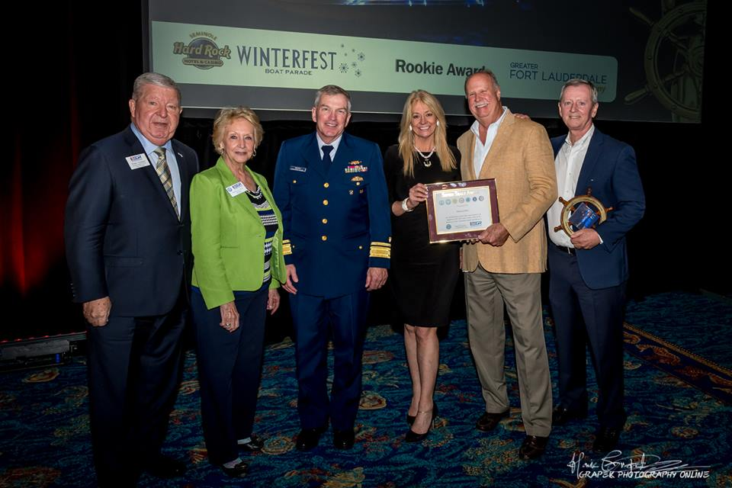
Peter Caspari, Rebecca Heinl, Rear Admiral Peter Brown, Lisa Scott-Founds (President & CEO, Winterfest, Inc.) Billy Smith and Bob Saxon

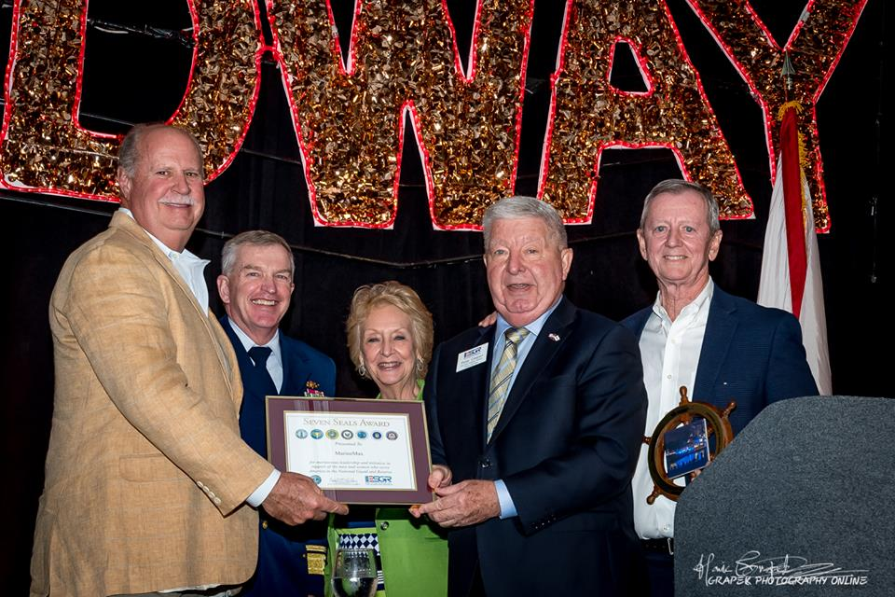 Billy Smith, Rear Admiral Peter Brown, Rebecca Heinl, Peter Caspari, and Bob Saxon

To see more photos of the Winterfest Captains’ Cup Awards Dinner presented by the Greater Fort Lauderdale Convention & Visitors Bureau – view the Parade’s Social Media or https://winterfestparade.com/photos

# # #

About Winterfest, Inc.
Winterfest is a Florida not-for-profit organization based in Broward County that produces a variety of events including the free public event known as "The World’s Most Watched Boat Parade." Millions via television and approximately one million spectators view the Parade on the 12-mile route. Winterfest also hosts annual events to enhance the community’s image and provide unique, wholesome family entertainment. For more information on Winterfest, please contact the office at (954) 767-0686 or their website: www.winterfestparade.com.

About Greater Fort Lauderdale
From the seagrass to the sawgrass, Greater Fort Lauderdale, located in Broward County, boasts more than 34,000 lodging accommodations at a variety of hotels, luxury spa resorts, and Superior Small Lodgings reflecting a vibrant cosmopolitan vibe. Visitors enjoy 23 miles of Blue Wave certified beaches, discover 300+ miles of inland waterways that run from the Intracoastal Waterway to the Everglades, dine at thousands of restaurants and eateries, get immersed in a thriving arts and culture scene and indulge in top shopping.
For more information, contact the Greater Fort Lauderdale Convention & Visitors Bureau at (800) 22-SUNNY or visit sunny.org. Get social and engage with Greater Fort Lauderdale on social media channels including Facebook, Twitter, Instagram, and Pinterest: @visitlauderdale.
About Seminole Hard Rock Hotel & Casino
Seminole Hard Rock Hotel & Casino is South Florida’s iconic entertainment destination located minutes from Fort Lauderdale’s world-famous beach. The AAA Four Diamond-rated resort features 469 luxury guest rooms and suites, award-winning restaurants, a lagoon-style pool and Beach Club Bar & Grill, a Hard Rock-inspired spa, premium meeting and convention space and a 5,500-seat Hard Rock Live concert arena. The casino offers more than 100 table games, 2,000 of the most popular slots and a poker room. Fine dining options include Council Oak Steaks & Seafood, the resort’s signature steakhouse, and Kuro, a luxe and socially vibrant restaurant offering new-style Japanese cuisine. In the heart of the hotel is L Bar, a sophisticated, contemporary lounge showcasing handcrafted classic cocktails with a twist. Contemporary and casual eateries, include Blue Plate, the hotel’s 24-hour diner-inspired restaurant; Constant Grind, a gourmet coffee and pastry shop; and the ever-famous Hard Rock Cafe – Hollywood, part of Hard Rock’s 178 globally recognized rock ‘n’ roll restaurants.For more information, call 800-937-0010, visit us online at www.seminolehardrockhollywood.com, or follow us on Facebook: @SeminoleHardRockHollywood, Twitter: @HardRockHolly, Instagram: @HardRockHolly

