FOR IMMEDIATE RELEASE
August 29, 2017
Media Contact:
Kristen Noffsinger Senior VP, Luxury PR Group
954-464-7388
Kristen@luxuryprgroup.com
www.LuxuryPRGroup.com
Photo of 2016 Jr. Captain
Photos of other past Jr. Captains and nominees are available upon request.

*** PRESS ALERT ***

Calling All Broward County Non-Profit Organizations -

Winterfest now accepting nominations for
2017 Junior Captain
The Seminole Hard Rock Winterfest Boat Parade is now accepting nominees from Broward County Non-Profit Organizations to be part of this year’s Winterfest Junior Captain Program powered by FPL
FORT LAUDERDALE, FL (August 29, 2017) – Winterfest, Inc. is known for its spectacular waterway Parade. Within this signature event is a program directed towards Broward County’s non-profits. Eight years ago, the Winterfest Junior Captain program was created as a legacy of 15-year-old Amanda Blake who battled osteosarcoma, a rare form of bone cancer. The Wasie Foundation and the Jessica June Children’s Cancer Foundation introduced this young cancer warrior to Winterfest, Inc. and she became an angelic face of hope in the battle against all odds during the first year of the program. Winterfest Advisory Member, Jen Klaassens with its President & CEO, Lisa Scott-Founds, and Event Director, Dawn Read, met Amanda prior to losing her battle. This monumental gathering changed the tradition of the Parade forever.
Amanda Blake's legacy continues as Winterfest annually honors a child nominated by a Broward County non-profit organization. The nominees must be 16 years or under and best represent the services provided by the charity. The Winterfest Junior Captain Contest is social media based and promotes the participating non-profits within Winterfest’s platforms giving additional awareness of the organization during cross promotions. Four years ago, FPL dedicated support to the program with a fully decorated showboat. The winning nominee, family and non-profit organization receive 25 tickets aboard the Jr. Captain Showboat powered by FPL with the child’s name and charity in lights. All nominees receive tickets to enjoy the Seminole Hard Rock Winterfest Boat Parade aboard the Santa Showboat sponsored by Joe DiMaggio Children’s Hospital.
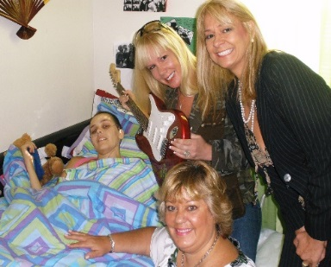
The contest runs in September. For more information on how you submit a nominee today to represent a Broward County non-profit organization, please call 954.767.0686 or visit WinterfestParade.com for more details.

###
About Winterfest, Inc.
Winterfest is a Florida not-for-profit organization based in Broward County that produces a variety of events including the free public event known as "The World’s Most Watched Boat Parade." Millions via television and approximately one million spectators view the Parade on the 12-mile route. Winterfest also hosts annual events to enhance the community’s image and provide unique, wholesome family entertainment. For more information on Winterfest, please contact the office at (954) 767-0686 or their website: www.winterfestparade.com.

About FPL (Florida Power & Light Company)
Florida Power & Light Company is the third-largest electric utility in the United States, serving more than 4.8 million customer accounts or more than 10 million people across nearly half of the state of Florida. FPL's typical 1,000-kWh residential customer bill is approximately 30 percent lower than the latest national average and, in 2015, was the lowest in Florida among reporting utilities for the sixth year in a row. FPL's service reliability is better than 99.98 percent, and its highly fuel-efficient power plant fleet is one of the cleanest among all utilities nationwide. The company was recognized in 2015 as one of the most trusted U.S. electric utilities by Market Strategies International. A leading Florida employer with approximately 8,800 employees, FPL is a subsidiary of Juno Beach, Fla.-based NextEra Energy, Inc. (NYSE: NEE), a clean energy company widely recognized for its efforts in sustainability, ethics and diversity, and has been ranked No. 1 in the electric and gas utilities industry in Fortune's 2016 list of "World's Most Admired Companies." NextEra Energy is also the parent company of NextEra Energy Resources, LLC, which, together with its affiliated entities, is the world's largest generator of renewable energy from the wind and sun. For more information, visit these websites: www.NextEraEnergy.com, www.FPL.com, www.NextEraEnergyResources.com.
About Seminole Hard Rock Hotel & Casino
Seminole Hard Rock Hotel & Casino is South Florida’s iconic entertainment destination located minutes from Fort Lauderdale’s world-famous beach. The AAA Four Diamond-rated resort features 469 luxury guest rooms and suites, award-winning restaurants, a lagoon-style pool and Beach Club Bar & Grill, a Hard Rock-inspired spa, premium meeting and convention space and a 5,500-seat Hard Rock Live concert arena. The casino offers more than 100 table games, 2,000 of the most popular slots and a poker room. Fine dining options include Council Oak Steaks & Seafood, the resort’s signature steakhouse, and Kuro, a luxe and socially vibrant restaurant offering new-style Japanese cuisine. In the heart of the hotel is L Bar, a sophisticated, contemporary lounge showcasing handcrafted classic cocktails with a twist. Contemporary and casual eateries, include Blue Plate, the hotel’s 24-hour diner-inspired restaurant; Constant Grind, a gourmet coffee and pastry shop; and the ever-famous Hard Rock Cafe – Hollywood, part of Hard Rock’s 178 globally recognized rock ‘n’ roll restaurants.For more information, call 800-937-0010, visit us online at www.seminolehardrockhollywood.com, or follow us on Facebook: @SeminoleHardRockHollywood, Twitter: @HardRockHolly, Instagram: @HardRockHolly

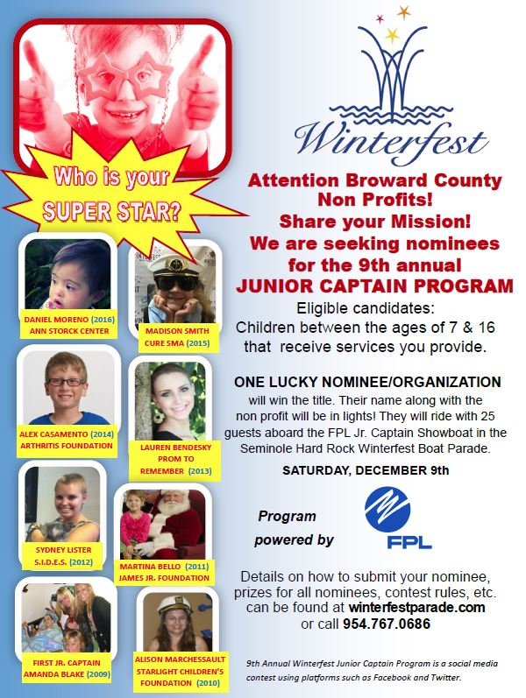

LIST OF PAST WINNERS:
2009: Amanda Blake - Jessica June Children’s Cancer Foundation
2010: Alison Marchessault – Starlight Children’s Foundation
2011: Martina Bello – James Jr. Fund
2012: Sydney Lister – S.I.D.E.S. (Sydney’s Incredible Defeat of Ewing’s Sarcoma)
2013: Lauren Bendesky – A Prom to Remember
2014: Alex Casamento - Arthritis Foundation
2015: Madison Smith – Cure SMA (Spinal Muscular Atrophy) South Florida Chapter
2016: Daniel Moreno (see image below) – Ann Storck Center
