NEWS RELEASE

FOR MORE INFORMATION:
Kathy Keleher, Winterfest, Inc.
954-767-0686, kathy@winterfestparade.com
Website: winterfestparade.com
FB: winterfest.parade
Twitter: WinterfestInc
#WinterfestFL17

Winterfest Announces April Renee Kirk as the Poster Artist for the 2017 Boat Parade.

FORT LAUDEDALE, FL (xx xx, 2017) – April Renee Kirk, a painter and the Executive Director of the Historic Stranahan House Museum, selected to create the poster for the 46th Seminole Hard Rock Winterfest Boat Parade. With her acrylic paint and paint brushes, Kirk envisions a melodious night on paper to showcase this year’s theme for the parade — “Broadway on Parade.”
For nearly 20 years, Kirk helped the community by volunteering for nonprofits. Currently, she is involved with City of Fort Lauderdale Community Services Board, Las Olas Association, Salvation Army of Broward County, and the Red Shield ReDesign Bash. She is the co-founder of the Native Reel Cinema Fest. In addition, she has experience with the Broward County Chapter of the Association of Fundraising Professionals and Leadership Broward.
The Seminole Hard Rock Winterfest Boat Parade will take place December 9th on the New River in downtown Fort Lauderdale, starting at 6:30 p.m. The event will showcase entertainment for all ages, aboard private boats, showboats and corporate entries decorated for the theme.
“We honor April Kirk’s dedication to the community, and we look forward to seeing her artistic style in this year’s poster,” said Lisa Scott-Founds, Winterfest CEO and President. “The fun elements of Broadway will be highlighted through April Kirk’s brushstrokes.”
April Renee Kirk stated, “I love Fort Lauderdale. Born at Broward General and raised on the edge of the Everglades, I have seen the wonderful transformation of this city over the years.
I love my life. I am both a museum director and a painter. Every day I have the privilege of being in the most beautiful and historic home in Broward County, the Historic Stranahan House Museum. In the evenings, I translate snapshots of this wonderful community into my own paintings. I strive to intertwine history and the arts in everything I do.
I love my home. I love the giant sky, the flat land, the abundant water, the diverse people, and the unique ecosystem. I love the sights and sounds and tastes of my home. I get lost in one ripple in the River and want to translate that blue onto canvas. I see diamonds floating on concrete as cars navigate the roads during sunset. I enjoy the contrast of white against blue against gold.
Everything I see I want to capture in paint so others can see the beauty that I do.”
About April Renee Kirk

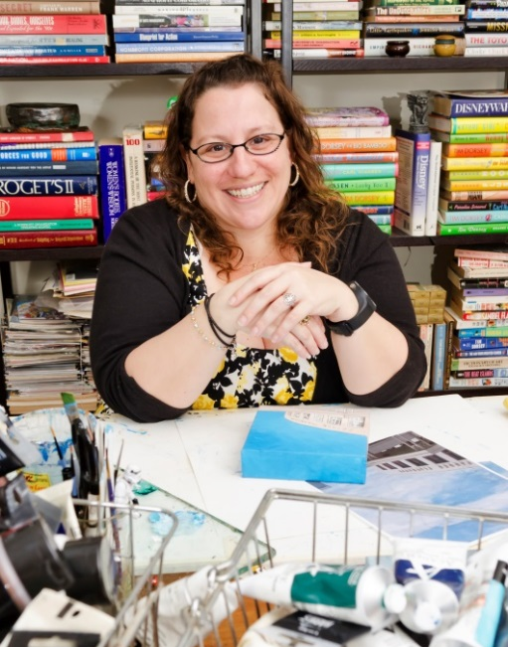
April Kirk is a resident of Fort Lauderdale, the Executive Director of the Historic Stranahan House Museum, and a painter. A native of Broward County, Kirk is a graduate of Pine Crest School and received a Bachelor of Arts in Studio Art with a concentration in painting and printmaking and a Bachelor of Arts in Art History from Queens College in Charlotte, North Carolina.
Kirk seeks inspiration for her paintings from old family photographs, pop culture, and her surroundings. Paintings often are created as part of a larger series such as cat portraiture, Converse shoes, or the latest series, the City of Fort Lauderdale. The paintings currently on display at Fort Lauderdale City Hall all represent iconic images of Fort Lauderdale including the Water Tower and Lester’s Diner.
Additional paintings in this series can be found at: Facebook.com/AprilReneeKirkArtist or AprilReneeKirk.com
When not painting, Kirk creates a collage that re-image comic book artwork into both two dimensional and three dimensional pieces including paper, wood boxes, and glass ornaments.
“

About Winterfest, Inc.
Winterfest is a Florida not-for-profit organization based in Broward County that produces a variety of events including the free public event known as "The World’s Most Watched Boat Parade." Millions via television and approximately one million spectators view the Parade on the 12-mile route. Winterfest also hosts annual events to enhance the community’s image and provide unique, wholesome family entertainment. For more information on Winterfest, please contact the office at 954-767-0686 or their website: www.winterfestparade.com.

About Seminole Hard Rock Hotel & Casino
Seminole Hard Rock Hotel & Casino is South Florida’s iconic entertainment destination located minutes from Fort Lauderdale’s world-famous beach. The AAA Four Diamond-rated resort features 469 luxury guest rooms and suites, award-winning restaurants, a lagoon-style pool and Beach Club Bar & Grill, a Hard Rock-inspired spa, premium meeting and convention space and a 5,500-seat Hard Rock Live concert arena. The casino offers more than 100 table games, 2,000 of the most popular slots and a poker room. Fine dining options include Council Oak Steaks & Seafood, the resort’s signature steakhouse, and Kuro, a luxe and socially vibrant restaurant offering new-style Japanese cuisine. In the heart of the hotel is L Bar, a sophisticated, contemporary lounge showcasing handcrafted classic cocktails with a twist. Contemporary and casual eateries, include Blue Plate, the hotel’s 24-hour diner-inspired restaurant; Constant Grind, a gourmet coffee and pastry shop; and the ever-famous Hard Rock Cafe – Hollywood, part of Hard Rock’s 178 globally recognized rock ‘n’ roll restaurants.For more information, call 800-937-0010, visit us online at www.seminolehardrockhollywood.com, or follow us on Facebook: @SeminoleHardRockHollywood, Twitter: @HardRockHolly, Instagram: @HardRockHolly

# # #

