NEWS RELEASE
FOR MORE INFORMATION:
Kathy Keleher, Winterfest, Inc.
954-767-0686, kathy@winterfestparade.com
Written by: Meridith Smith
Website: winterfestparade.com
FB: winterfest.parade
Twitter/Instagram: WinterfestInc
#winterfestfl17

NEWS RELEASE
FOR MORE INFORMATION:
Kathy Keleher, Winterfest, Inc.
954-767-0686, kathy@winterfestparade.com
Website: winterfestparade.com
FB: winterfest.parade
Twitter/Instagram: WinterfestInc
#winterfestfl17

SEMINOLE HARD ROCK Winterfest®
Black Tie Ball is the
social Affair of the Season!

Seminole Hard Rock Winterfest® Black Tie Ball Kicks off the Holiday Season at Hard Rock Live with Jersey Boys

Mary: Do you have a nickel?
Frankie Valli: Yeah.
Mary: Call your mother, you're going to be home late.

The long awaited social event of the year is ready to rock your world December 2nd! The Seminole Hard Rock Winterfest® Black Tie Ball presented by Ford in association with Republic National Distributing Company will kick off the holiday season in elegant South Florida Style.

The Red Carpet Reception presented by the Law Offices of Anidjar & Levine kicks off the evening with Champagne Taittinger and cocktails made with Brugal Rum, Deep Eddy Vodka, Maestro Dobel Tequila with wines flowing. Guests will have had the opportunity to bid on items in the Fidelity Investments Silent Auction prior to attending and during the event. Items include jewels, cruises, vacations, airline tickets from Southwest Airlines – the official airline of Winterfest, sports memorabilia, art and more simply by connecting to https://qtego.net/qlink/winterfest on their phone or computer (you don’t have to attend to bid).
The Seminole Hard Rock Hotel & Casino will convert Hard Rock Live into the glitz of the Four Seasons live on stage. There will be special performances direct from the musical “Jersey Boys” brought to you by Broadway Across America and LuxuryPR. Riverwalk Trust’s president, Eugenia Ellis will be honored as this year’s Belle-of-the Ball and Kenneth Ortner, PA and past chairman of Winterfest will be honored as Commodore. The evening will include the who’s who and fashionistas wearing Zola Keller gowns. Ball Co-Chairs Susan Renneisen and Danielle Dattile have an amazing evening in store for over 900 guests. Guests will take souvenir photos by Twinbrook Insurance Brokerage, Inc., fun photo booths from Ultimate Software and Ford and swag bags compliments of Fifth Third Bank.
The Black Tie Ball is the perfect holiday event in anticipation of the 46th Annual Seminole Hard Rock Winterfest Boat Parade. Tables of 10 range from $2500-$5000 and reservations are now being accepted. This highly desirable event will sell out quickly. Didn’t get the digital invite? Click on the link: http://bit.ly/WinterfestBall2017, visit winterfestparade.com or call 954.767.0686 for more details. Mark your calendar for the Seminole Hard Rock Winterfest Boat Parade on Saturday, December 9th with the theme “Broadway on Parade.”
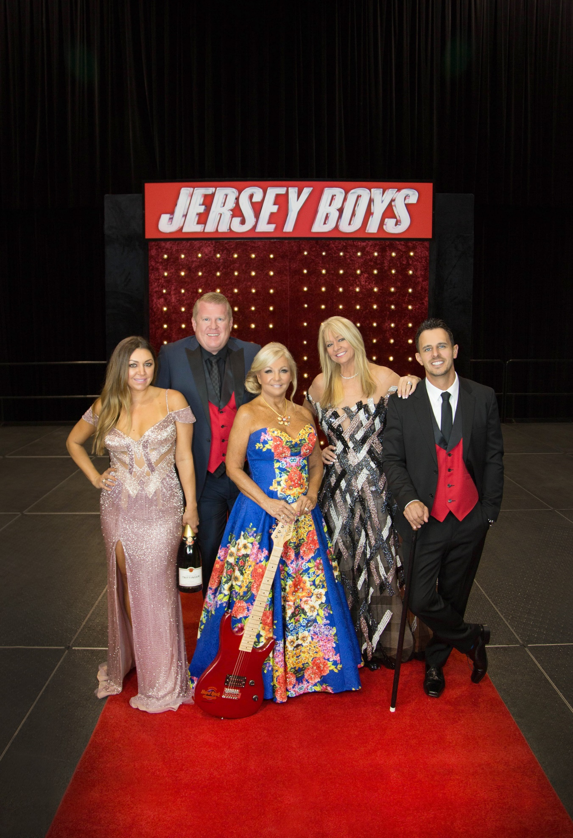

From left to right (names without companies):
Danielle Dattile, David Boothe, Susan Renneisen., Lisa Scott-Founds and Gregg Snowden
Jersey Boys backdrop by Designs by Sean. Gowns by Zola Keller. Jewelry by Carroll’s Jewelers. Photo by Kara Starzk Photography

From left to right (names without companies):
Danielle and David – Republic National Distributing Co.
Susan Renneisen – Seminole Hard Rock
Lisa Scott-Founds – Winterfest, Inc.
Gregg Snowden - Ford
INSIDE PHOTOS

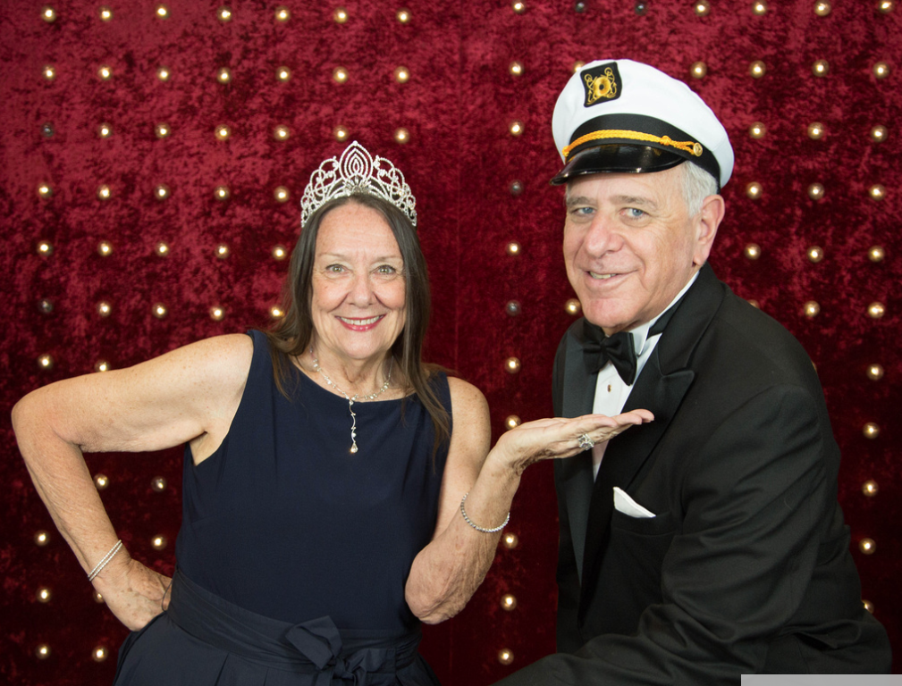
Belle of the Ball: Eugenia Ellis and Commodore: Ken Ortner
Photo by Kara Starzk Photography

COMMITTEE PHOTOS:
Committee Photos by Ginny Fujino – Black Tie South Florida
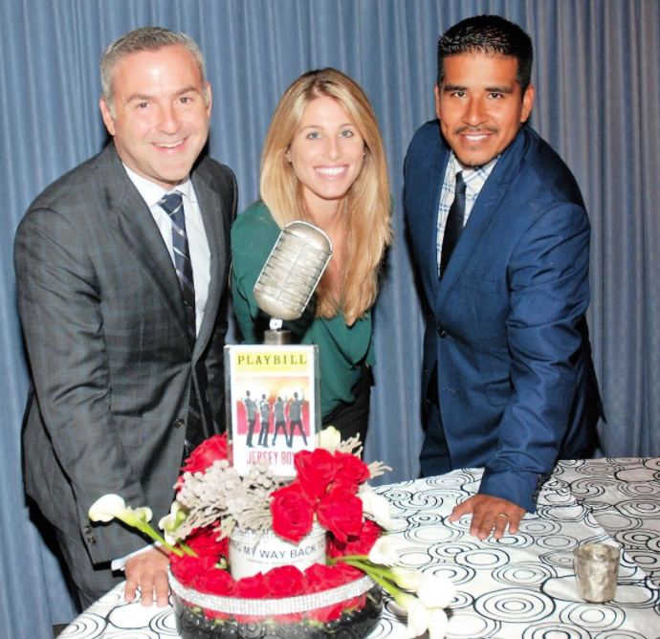
Glen B. Levine (Anidjar & Levine), Sarah DeJulio (Kobrand) and Jon Paul Villanueva (Ford)

Katie Walters, Wendy Liebowitz, Doug Jones, Marianna Abbate and Micki Scavone

Brigitte Doria, Lori Perlman, Arlette Spaniak, Paula Klein, Denise Casale, and Ginny Fujino

# # #
About Winterfest, Inc.
Winterfest is a Florida not-for-profit organization based in Broward County that produces a variety of events including the free public event known as the Seminole Hard Rock Winterfest Boat Parade - "The World’s Most Watched Boat Parade." Approximately one million spectators view the Parade on the 12-mile route along with millions more via television and the internet bringing National and International recognition to South Florida. Winterfest also hosts annual events to enhance the community’s image and provide unique, wholesome family entertainment. For more information on Winterfest, please contact the office at (954) 767-0686 or their website: www.winterfestparade.com.

