FOR IMMEDIATE RELEASE
May 26, 2016
Media Contact:
Kristen Noffsinger Senior VP, Luxury PR Group
954-464-7388
Kristen@luxuryprgroup.com
www.LuxuryPRGroup.com

Winterfest named as one of the best parades in South Florida.
Winterfest, a Florida not-for-profit organization and producers of the “Greatest Show on H20," has been listed by BizBash as one of the top three parades in the South Florida market.

FORT LAUDERDALE, FL (May 25, 2016) - Winterfest, Inc. has now been recognized as a top runner among it’s parading peers in South Florida. "The World’s Most Watched Boat Parade," has been listed by BizBash as one of the top three in parades/festival category in the South Florida market solidifying the title Top 100 Events for 2016. The announcement was made May 24, 2016.
South Florida is an eclectic melting pot of people and cultures, and the events presented are no different. From lavish see-and-be-seen fund-raising galas to cutting-edge conferences to over-the-top pool parties, South Florida residents frequently gather with purpose. The Seminole Hard Rock Winterfest Boat Parade is one of these "Must See Events" which has economic impact, buzz, innovation, and prominence within the communities. To choose and rank the annual events on this list, BizBash considers these factors along with the event's prominence within the community it intends to serve. (bizbash.com/top100)
“Winterfest’s economic impact on the community is estimated at more than $50 million per year. Winterfest, Inc., the sole producers the Seminole Hard Rock Winterfest Boat Parade, has work for 45 years to encourage community connections while celebrating the boating paradise we live in during December,” says Lisa Scott-Founds, president and CEO of Winterfest. “We are proud to be the signature event of South Florida and encourage everyone to embrace this year’s theme, Comics & Cartoons Rockin’ The Night Away.” The organization is working with Florida SuperCon during their anniversary year to bring Superheroes and Showboats together to create a fantastically successful evening on December 10, 2016.
For more information on how to enter your boat for only $35 or purchase tickets, visit winterfestparade.com or call 954-767-0686.

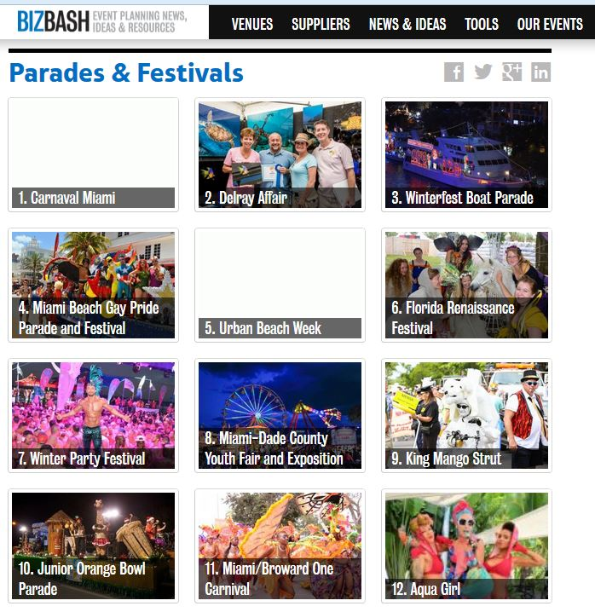

# # #
ABOUT BIZBASH
In the dynamic live gathering industry, BizBash is the largest media source for both event pros and “hidden planners” with nearly 225,000 monthly users. Live Gatherings serviced by the BizBash suite of products include: exhibitions, conferences and meetings, training and learning, marketing and PR, fund-raising and galas, celebrations and weddings, incentive and travel, and government and ceremonial. Visit www.bizbash.com and follow @BizBash on Twitter or www.facebook.com/bizbash.

About Winterfest, Inc.
Winterfest is a Florida not-for-profit organization based in Broward County that produces a variety of events including the free public event known as the Seminole Hard Rock Winterfest Boat Parade - "The World’s Most Watched Boat Parade." Approximately one million spectators view the Parade on the 12-mile route along with millions more via television and the internet bringing National and International recognition to South Florida. Winterfest also hosts annual events to enhance the community’s image and provide unique, wholesome family entertainment. For more information on Winterfest, please contact the office at (954) 767-0686 or their website: www.winterfestparade.com.

About Seminole Hard Rock Hotel & Casino
Seminole Hard Rock Hotel & Casino in Hollywood, Florida, located minutes from Fort Lauderdale’s world-famous beach, features a AAA Four Diamond resort with 469 luxury rooms and suites, award-winning restaurants, high-energy nightlife, a lagoon-style pool and Beach Club, a Hard Rock-inspired spa, and premium meeting and convention space. As South Florida’s premier entertainment destination, Seminole Hard Rock hosts top-name acts at its 5,500–seat Hard Rock Live concert arena and offers more than 100 table games, 2,000 of the most popular slots and a stand-alone poker room. Fine dining options include Council Oak Steaks & Seafood, the resort’s signature steakhouse, and Kuro, a luxe and socially vibrant restaurant offering new-style Japanese cuisine. The resort also features contemporary and casual eateries, including Blue Plate, the hotel’s 24-hour diner-inspired restaurant; Constant Grind, a gourmet coffee and pastry shop; and the ever-famous Hard Rock Cafe - Hollywood, part of Hard Rock’s 163 globally recognized rock ‘n’ roll restaurants.
For more information, call 800-937-0010, visit us online at www.seminolehardrockhollywood.com, or follow us on Facebook: @SeminoleHardRockHollywood, Twitter: @HardRockHolly, Instagram: @HardRockHolly

