NEWS RELEASE
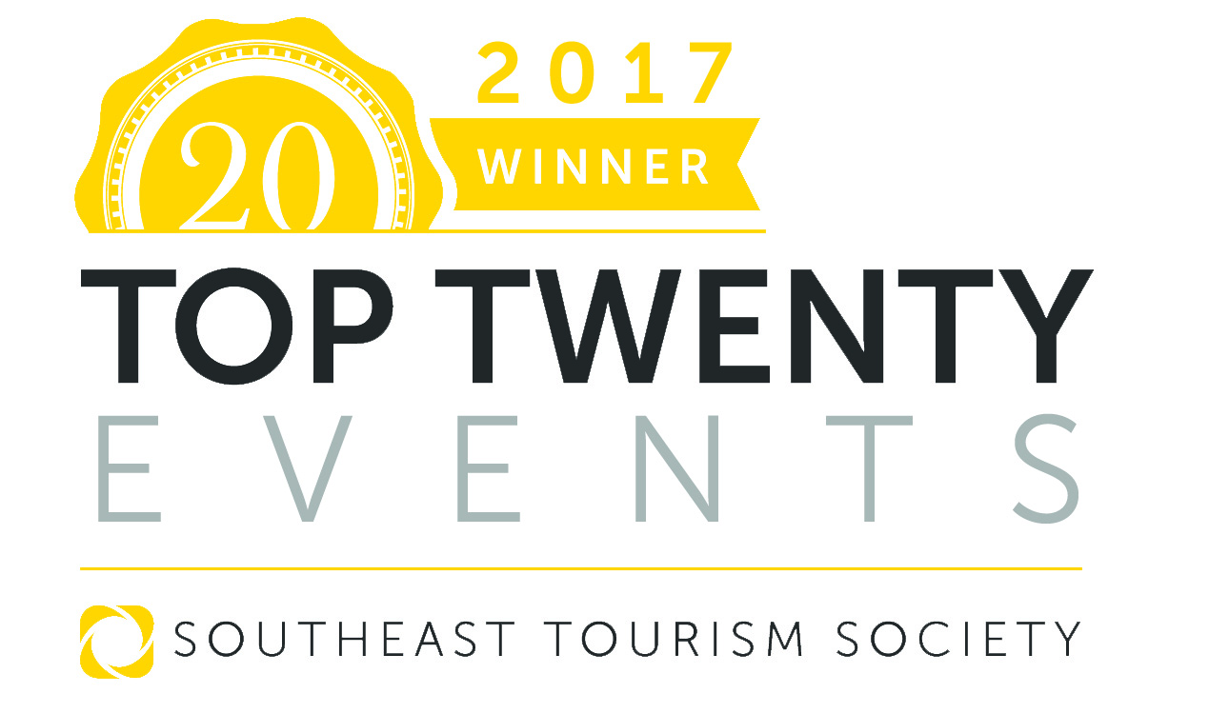
FOR MORE INFORMATION:
Kathy Keleher, Winterfest, Inc.
954-767-0686, kathy@winterfestparade.com
Website: winterfestparade.com
FB: winterfest.parade
Twitter: WinterfestInc
#WinterfestFL17

Southeast Tourism Society Selects Seminole Hard Rock Winterfest Boat Parade as an ‘STS Top 20 Event’

Travel industry organization has saluted region’s best events since 1985

ATLANTA, Ga. August 1, 2017 – Southeast Tourism Society has named Seminole Hard Rock Winterfest Boat Parade one of the STS Top 20 Events in the Southeast for December 2017.

This year’s Parade is December 9, 2017. The STS Top 20 Festival and Event Awards have highlighted programs around the Southeast since 1985.
Travel industry experts select 20 events per month, and STS publicizes them throughout the United States. The complete list is published on two websites: Southeast Tourism Society and Travel Media Press Room. The website listing reads:
December 9, 2017, Seminole Hard Rock Winterfest Boat Parade, Fort Lauderdale, FL, https://WinterfestParade.com/
The world’s most watched parade travels the Intracoastal waterways, 12 miles in Broward County from Fort Lauderdale, north to Lake Santa Barbara in Pompano Beach. The parade hosts brightly embellished boats carrying celebrities, musical groups, beauty queens and other thrilling entries such as a floating Broadway barge. The theme for the parade is “Broadway on Parade.” The International Festival and Events Association named Winterfest to its top 20 Parades in the World. Come see why 1 million people come to watch this holiday spectacle every year!

“The Southeast Tourism Society’s Top 20 Festival and Event list is an excellent guide for the Southeast’s visitors, residents and travel writers. The events selected represent the best, and often most unique, activities in our region,” said Bill Hardman, president and CEO of the Southeast Tourism Society.

Events considered for the STS Top 20 recognition must be at least three years old and have attendance of at least 1,000. The online nomination link and submission deadlines are available at SoutheastTourism.org or by calling 770-542-1523.

# # #

About Southeast Tourism Society
STS, founded in 1983 and headquartered in Atlanta, Ga., is a non-profit organization dedicated to promoting tourism to and within 12 states – Alabama, Arkansas, Florida, Georgia, Kentucky, Louisiana, Mississippi, North Carolina, South Carolina, Tennessee, Virginia and West Virginia.

About Winterfest, Inc.
Winterfest is a Florida not-for-profit organization based in Broward County that produces a variety of events including the free public event known as "The World’s Most Watched Boat Parade." Millions via television and approximately one million spectators view the Parade on the 12-mile route. Winterfest also hosts annual events to enhance the community’s image and provide unique, wholesome family entertainment. For more information on Winterfest, please contact the office at 954-767-0686 or their website: www.winterfestparade.com.

