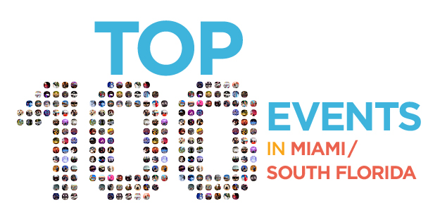
WINTERFEST CONTACT:
Kathy Keleher
954-767-0686
kathy@winterfestparade.com

BIZBASH CONTACT:
Grazia Mohren
646-839-6896
gmohren@bizbash.com

BIZBASH SELECTS SEMINOLE HARD ROCK WINTERFEST BOAT PARADE AS
ONE OF MIAMI/SOUTH FLORIDA’S TOP 100 EVENTS
Winterfest, Inc. is acknowledged as
one of the most powerful events making an impact in Miami/South Florida.

May 23,2017 — From galas and benefits, to entertainment, sporting events, and more, BizBash has announced its 2017 list of Top 100 Events in Miami/South Florida and has named Seminole Hard Rock Winterfest Boat Parade to this exclusive list. To select and rank these events, BizBash considers the event’s influence within the industry, in addition to innovation, reach, economic impact, and more.

Winterfest, Inc., which produces the Parade known as the “Greatest Show on H2O” and One of the Top Parades in the World, recently announced the theme for this 46th annual event “Broadway on Parade.” Set to sail along the Fort Lauderdale waterway on December 9, 2017, Winterfest will host 100 entries featuring the most spectatularly decorated mega yachts, barges, kayaks and privately owned vessels.

“So many high-profile events call Miami and South Florida home, and to choose the best from this diverse landscape is no easy task,” says Beth Kormanik, BizBash executive editor. “Today’s top events reflect a sharply honed sense of mission, thoughtful production, and engaged guests—factors that all contribute to their success.”

[PROOF / REWRITE QUOTE]
“Winterfest is very proud to be the signature event of South Florida and the Greater Fort Lauderdale area during the Winter Holidays season,” added Lisa Scott-Founds, President & CEO, Winterfest, Inc. “With over one million people watching along the waterway and millions more on television and streaming online, this parade has something for everyone.”

Seminole Hard Rock Winterfest Boat Parade and the rest of Miami/South Florida’s Top 100 Events list can be found at www.bizbash.com/top-100.

FOR MORE INFORMATION:
BizBash executive editor Beth Kormanik is available for additional comments. Photos are available upon request by contacting Winterfest.
About Winterfest, Inc.
Winterfest is a Florida not-for-profit organization based in Broward County that produces a variety of events including the free public event known as "The World’s Most Watched Boat Parade." Millions via television and approximately one million spectators view the Parade on the 12-mile route. Winterfest also hosts annual events to enhance the community’s image and provide unique, wholesome family entertainment. For more information on Winterfest, please contact the office at (954) 767-0686 or their website: www.winterfestparade.com.

ABOUT BIZBASH:
BizBash empowers event professionals with ideas, intelligence, and resources to create smarter events. Each month more than 225,000 unique users across North America and beyond look to BizBash for venue discovery, event style, technology, and tools for their next event. Visit us at www.bizbash.com. Follow us at @BizBash on Twitter and Instagram or www.facebook.com/bizbash

