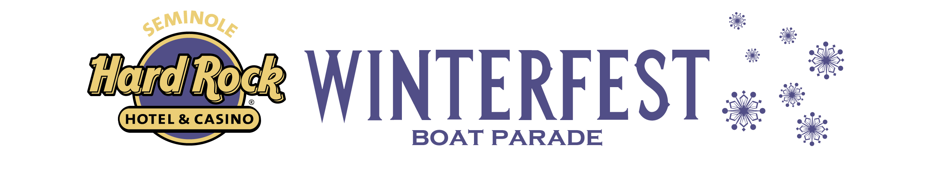
NEWS RELEASE

FOR MORE INFORMATION:
Kathy- Keleher, Winterfest, Inc.
954-767-0686, kathy@winterfestparade.com
Website: winterfestparade.com
FB: winterfest.parade
Twitter/Instagram: WinterfestInc
Editor’s Note: Hi-Res image of Big & Rich, click here:
https://winterfestparade.com/wp-content/uploads/2018/10/Big-Rich.jpg

Comin’ to Your City:
Big & Rich Named 2017 Seminole Hard Rock
Winterfest® Boat Parade Grand Marshals
WHO: Fort Lauderdale, FL (October 30, 2017) – Parade Organizers announced John Rich and Big Kenny, globally known as Big & Rich, as the Grand Marshals of the 46th Annual Seminole Hard Rock Winterfest® Boat Parade on Saturday, Dec. 9, 2017. Big & Rich will serve as ambassador for South Florida’s most acclaimed holiday celebration. The Country Music Legends will be donating their performance fee to charities supporting victims of the Vegas massacre, hurricane relief efforts, and their children’s charity.

WHAT: The Seminole Hard Rock Hotel & Casino will be hosting the “2017 Seminole Hard Rock Winterfest Boat Parade.” Big & Rich prepare to lead the Parade along the Fort Lauderdale waterways in true Grand Marshal style on December 9, 2017, at 6:30 p.m. On the night of the Parade, Big & Rich will be on the bow aboard the Grand Marshal Showboat Grand Floridian by JM Lexus waving to one million spectators along the shoreline and millions more at home.

WHEN: Saturday, December 9, 2017 starting at 6:30 PM

WHERE: Our 12-mile Parade route stretches from the New River to Lake Santa Barbara.

The Grandstand Viewing Area at Hugh Taylor Birch State Park:
3109 East Sunrise Boulevard
Fort Lauderdale, FL 33304

CONTACT: For more information on Winterfest, please contact the office at (954) 767-0686 or visit www.winterfestparade.com

About Big & Rich
Known for their high-energy shows and thrilling crowds across the country, Big & Rich are America’s technicolor cowboys, brothers-in-arms in service to the creed that great music has no boundaries. Individually, John and Big Kenny are first-rate musicians, songwriters, producers, and entertainers. Together, they are one of the most truly original musical forces ever unleashed on a welcoming world. With their one-of-a-kind vocal blend and musical styles drawing fans from all genres and ages. Don’t miss the FREAK PARADE when they are in your town.
Their latest single “California” is out now with the full album, Did It For The Party, to be released later this year. Some of their hit songs include “Save a Horse, Ride a Cowboy,” “8th of November,” “ Look At You,” Lost in this Moment," “Run Away with You,” “Lovin’ Lately” and “Comin’ to Your City.”

About Winterfest, Inc.
Winterfest is a Florida not-for-profit organization based in Broward County that produces a variety of events including the free public event known as the Seminole Hard Rock Winterfest Boat Parade - "The World’s Most Watched Boat Parade." Approximately one million spectators view the Parade on the 12-mile route along with millions more via television and the internet bringing National and International recognition to South Florida. Winterfest also hosts annual events to enhance the community’s image and provide unique, wholesome family entertainment. For more information on Winterfest, please contact the office at (954) 767-0686 or their website: www.winterfestparade.com.

About Seminole Hard Rock Hotel & Casino
Seminole Hard Rock Hotel & Casino in Hollywood, Florida, located minutes from Fort Lauderdale’s world-famous beach, features a AAA Four Diamond resort with 469 luxury rooms and suites, award-winning restaurants, high-energy nightlife, a lagoon-style pool and Beach Club, a Hard Rock-inspired spa, and premium meeting and convention space. As South Florida’s premier entertainment destination, Seminole Hard Rock hosts top-name acts at its 5,500–seat Hard Rock Live concert arena and offers more than 100 table games, 2,000 of the most popular slots and a stand-alone poker room. Fine dining options include Council Oak Steaks & Seafood, the resort’s signature steakhouse, and Kuro, a luxe and socially vibrant restaurant offering new-style Japanese cuisine. The resort also features contemporary and casual eateries, including Blue Plate, the hotel’s 24-hour diner-inspired restaurant; Constant Grind, a gourmet coffee and pastry shop; and the ever-famous Hard Rock Cafe - Hollywood, part of Hard Rock’s 167 globally recognized rock ‘n’ roll restaurants. For more information, call 800-937-0010, visit us online at www.seminolehardrockhollywood.com, or follow us on Facebook: @SeminoleHardRockHollywood, Twitter: @HardRockHolly, Instagram: @HardRockHolly

