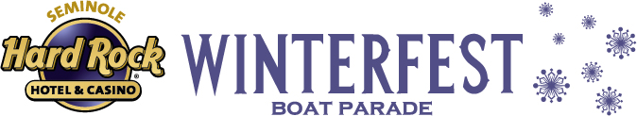
Winterfest® Cocktail Contest 2015 With


PRIZES

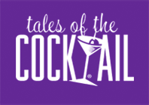
FIRST PLACE BARTENDER WINS $1000 CASH AND TICKETS TO “TALES OF THE COCKTAIL”!
The bartender who wins the mixology tasting will receive:
- $1000 in cash
- Tickets for two to “Tales of the Cocktail Festival” in New Orleans with r/t tickets on Spirit Airlines.
- The winning cocktail will be the official drink of Winterfest 2015 and will be featured at the Black Tie Ball and Grand Marshal Reception.
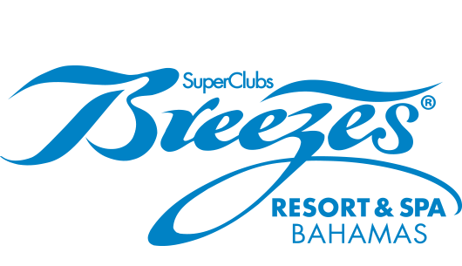
SOCIAL MEDIA:
- The establishment’s bartender with the most social media votes will host the Mixology Tasting.
- One random voter will win a vacation for two to Breezes Bahamas – Cable Beach in Nassau.
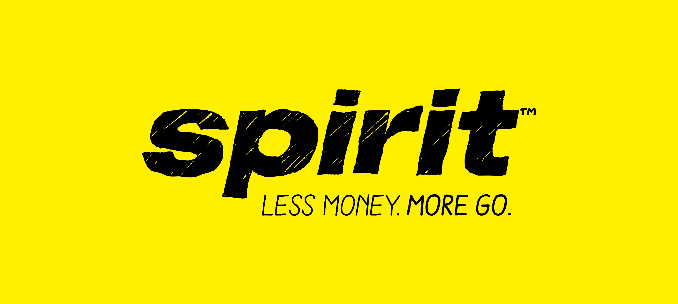

PARAMETERS AND RULES

THE DEAL: This contest will consist of two parts: general voting and mixologist tasting. Bartenders have until November 20, 2015 to craft, create, submit cocktails and email the cocktail name, recipe/ingredients, instructions and photo (photo of the Bartender with at least one of Republic National Distributing Company (RNDC) products used to make the cocktail) to cocktail@winterfestparade.com. (Limited to Broward County) All recipes, photos and submissions become property of Winterfest, Inc.

THE SPECIFICS: Cocktail must feature at least one of the following brands: Brugal Rum, Cointreau, Corralejo Tequila, Fireball, Russian Standard Vodka, Rum Chata, Templeton Rye Whiskey, The Botanist, The Macallan, Famous Grouse, and Prosecco, Pacific Rim or Bodega Trivento wines. ALL SPIRITS MUST BE REPUBLIC NATIONAL DISTRIBUTING COMPANY PRODUCTS. You may also use Stella Artois if the cocktail requires beer.

VOTING ON SOCIAL MEDIA: Voting is the most important part of the contest, encourage all of your friends and family to vote. Voting polls open October 15, 2015 at 12:01 a.m. and the contest will run until November 25th, 2015 at 11:59.
Where do you vote?
- Facebook- Facebook.com/Winterfest.parade
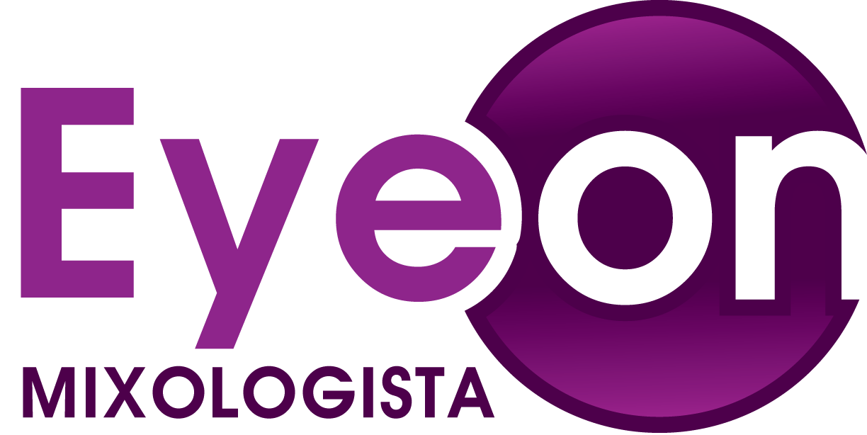
- Weblink- http://woobox.com/gsvhz5

MIXOLOGIST TASTING – November 20:
- The top ten bartenders will be filmed by EyeOnMixologista as they recreate their entries.
- The establishment of the bartender with the most social media votes will host the Mixology Tasting.
- These top entries will then be judged by RNDC Mixologist (or REPRESENTATIVE) and other celebrity judges.
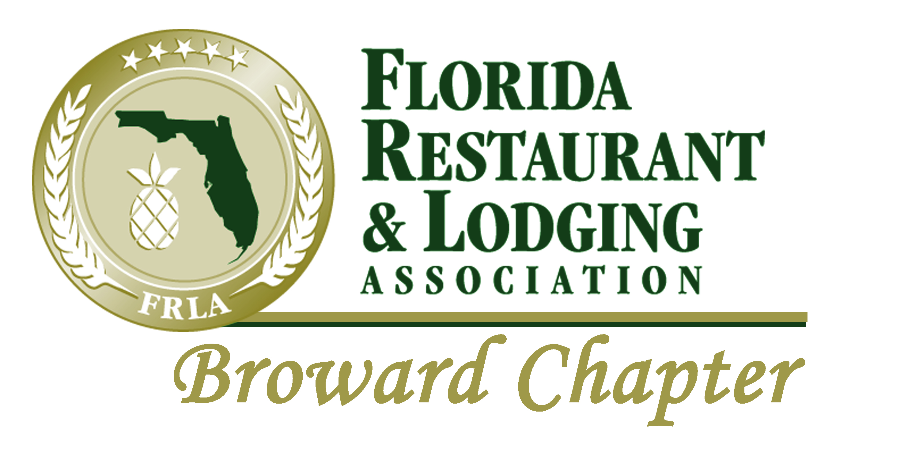
By Submitting an entry, Bartenders agree to the rules.

Contest Hashtags: #WinterfestCocktail #RNDCHappyHour

PRODUCT LIST with Suggested Hashtags (to include on your social media posts with the hashtag of your establishment):

Supplier: Republic National Distributing, Co.

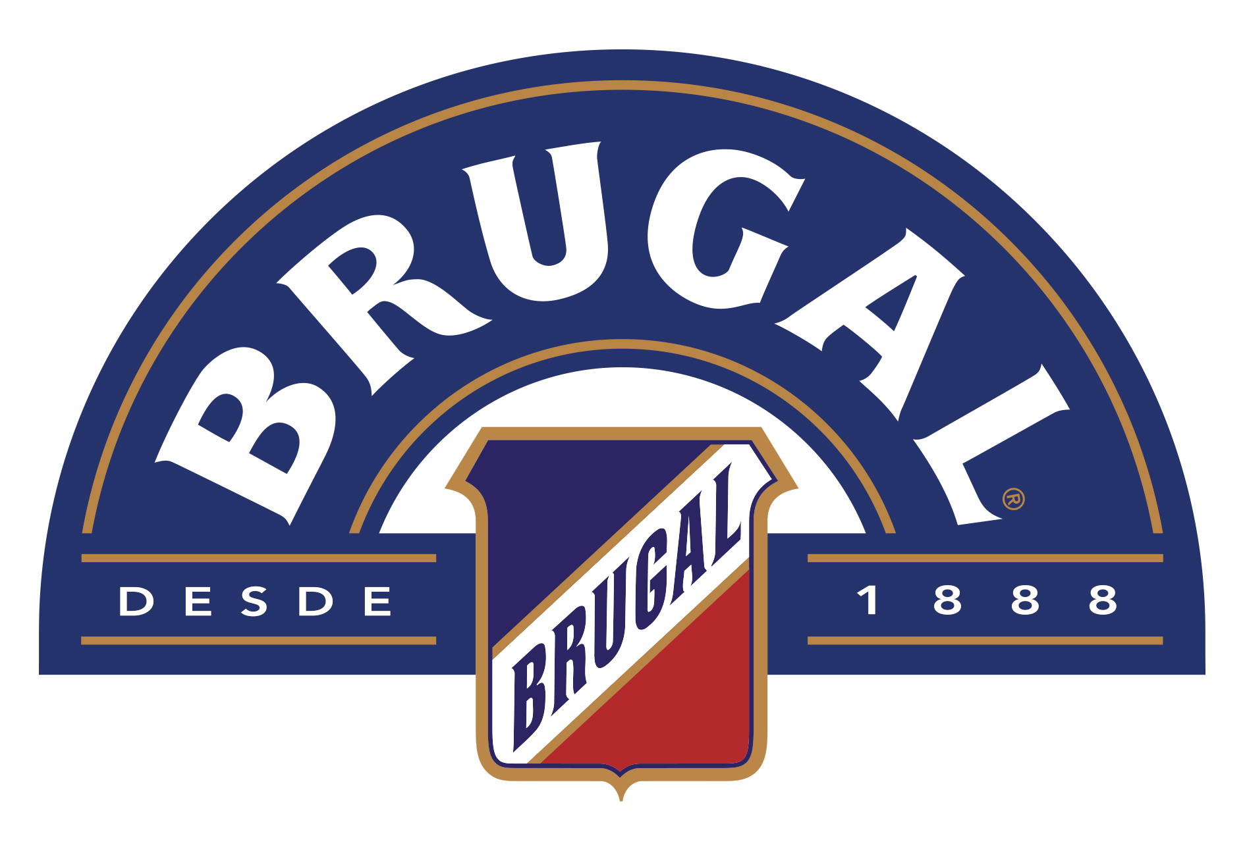
#BlendWithBrugal

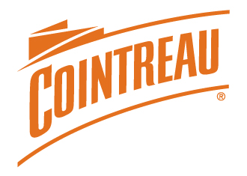
#CountreauCocktail

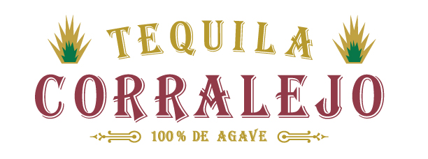
#CoolerWithCorralejo

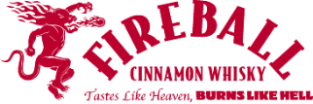
#BurningBartenders

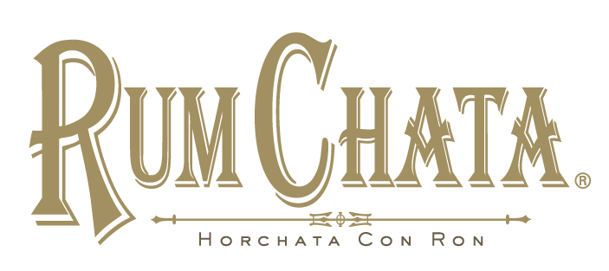
#ChataTime
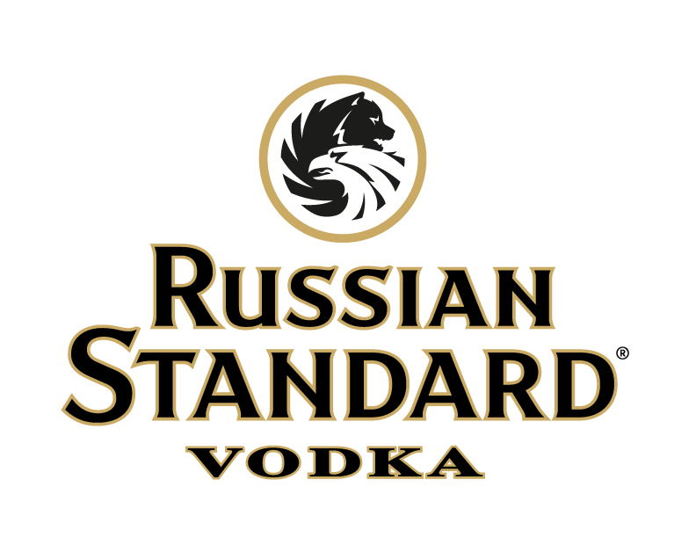
#vodkauthority

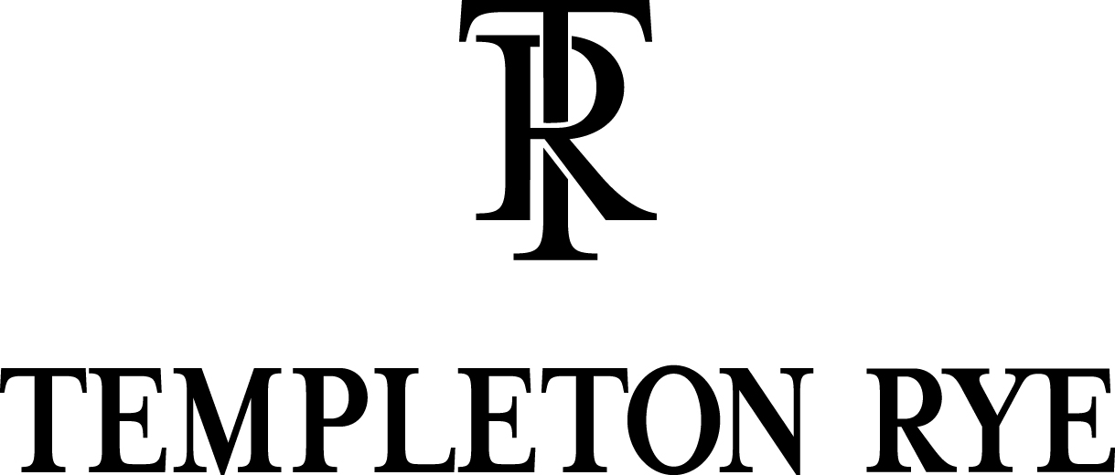
#TheGoodStuff

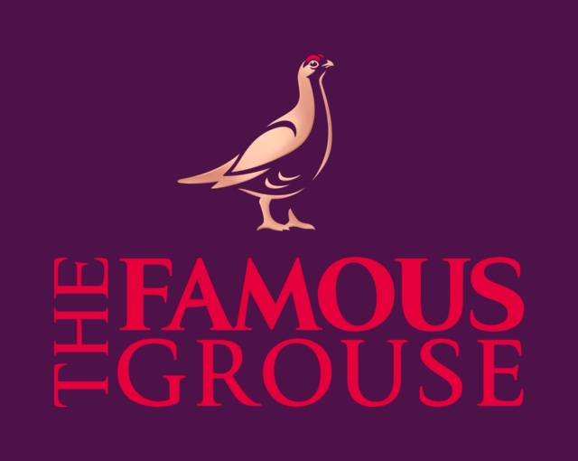
#famousgrouse

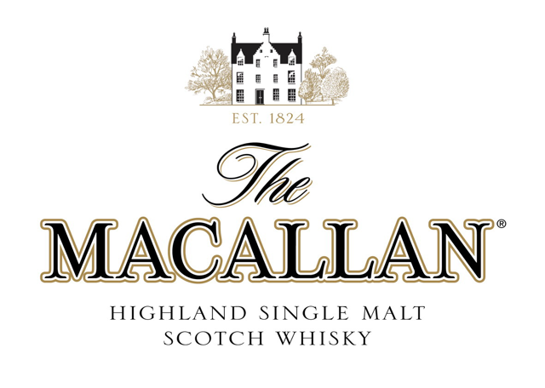
#macallan

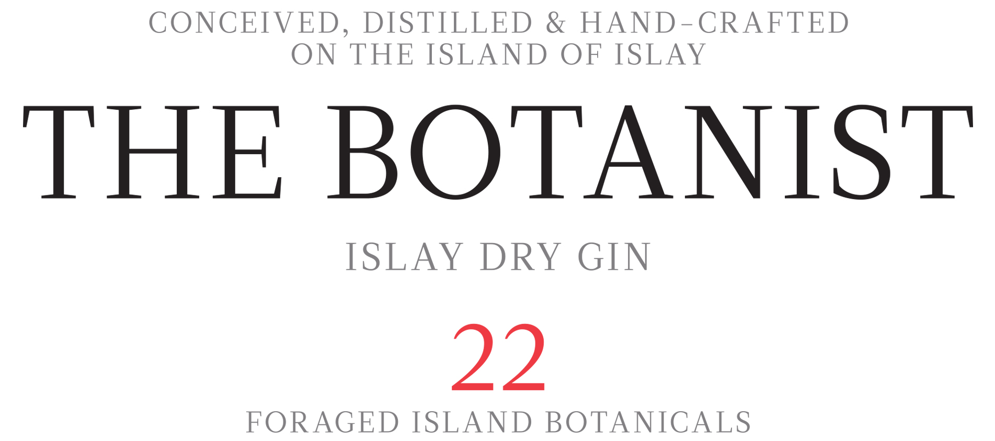

#TheBotanist

WINE LIST:

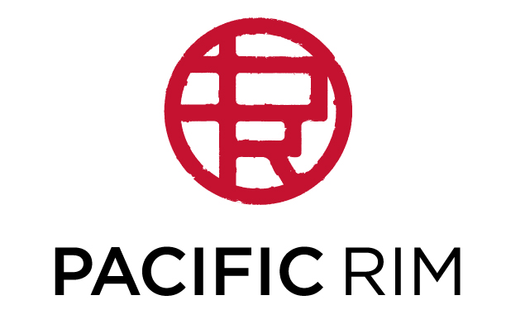
#PacificRim

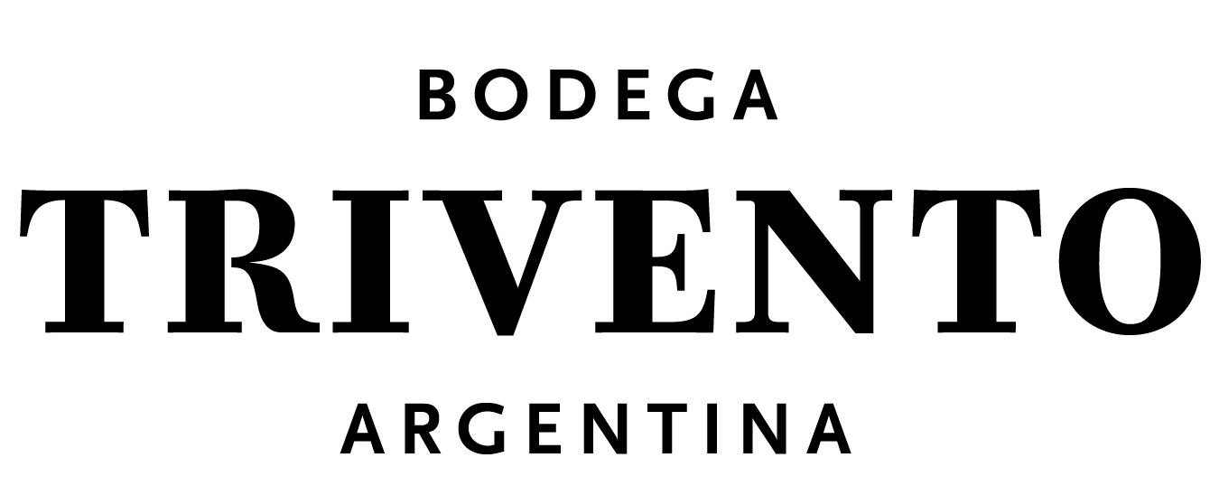
#trivento

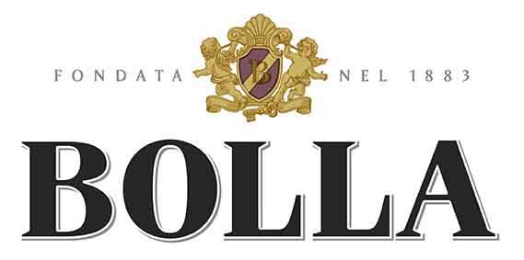
#Proseco

BEER:
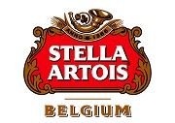
#StellaArtois

