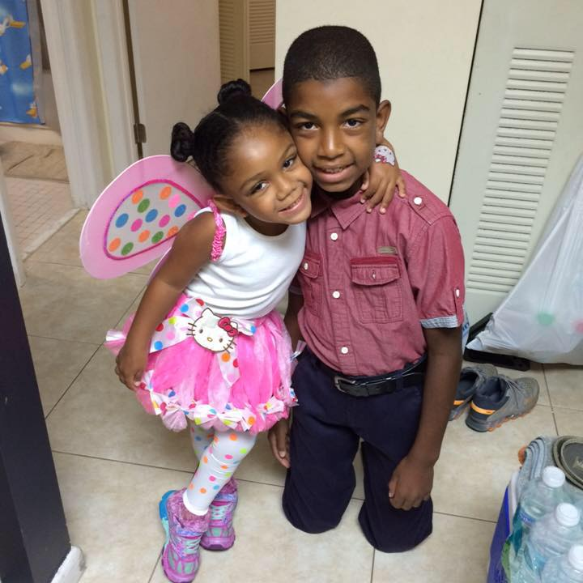

ZOË- SOARING BUTTERFLIES FOR TURNER SYNDROME –

http://woobox.com/zyzn4s

We were 5 months pregnant when my blood results came back from the ob-gyn office. These were the standard blood tests that check for Down Syndrome, etc. The nurse that called us said that our results showed we were at a high risk for having a baby with Trisomy 18. We did not know what that was and of course did our research to find out that it was a terminal condition and that a baby with Trisomy 18 does not normally live beyond a year old and has a multitude of physical and developmental problems. We were referred to a geneticist who explained Trisomy 18 in more detail and informed us that the only way to know for sure was to have an amniocentesis.

We left that morning feeling overwhelmed; our hearts were heavy as we tried processing the information. After a week, we decide that we wanted to know for sure if our baby girl had Trisomy 18. The results took 9 very long days. It was one late evening when we received a call from the geneticist and she said, “The results are back. Your baby doesn’t have Trisomy 18 but she does have Turner Syndrome.” We were elated that she did not have Trisomy 18 but we did not know what Turner Syndrome was. So we asked what it was and she said, “It means that your daughter will be of short stature, will have underdeveloped ovaries and will not be able to have children because she is missing a chromosome.” Our hearts sank and we cried and held each other for some time after that call. Then we prayed and met with the geneticist the following morning. She showed us medical books with pictures of girls with TS and explained that we would not know the degree of her medical, physical and developmental issues until after she was born. She then proceeded to tell us that we had 2 weeks to decide if we wanted to terminate the pregnancy. This was never an option for us, after all, we were her parents and she was a miracle. Whether she lived one day, 10 months or 10 years, with or without disabilities or abnormalities, she was our baby girl and we were going to love her as long as we could. So, as the time of her birth grew near we found out she had a ventricular septal defect (hole in her heart) and the cardiologist told us she may need to have open heart surgery but that we would not know until she was born.

On June 27, 2011 our Zoë was born at 1:11pm weighing 6lb 4oz. She was taken immediately to be assessed and other than having horrible edema in her left hand and both feet and having jaundice, she was doing great. Fast forward now 5 years later, the hole in her heart closed on its own by 6 months, she is on seizure medication (for petit mal seizures), she has had 2 surgeries, one for strabismus (to tighten her eye muscles) and one to remove her adenoids and tonsils due to sleep apnea, she has graduated from physical therapy sessions. She currently has occupational therapy and language/speech therapy several times a week and has a team of specialists who monitor her. It has not been easy, but by God’s grace we have been able to see the miracle of life and the beauty in each day. We could not imagine our life without our daughter and if you meet her, you would never know that this strong, little girl has been through so much. She is a very happy, animated and joyous child and she is definitely the social butterfly out of our family. We are so grateful that this little girl, who had less than 2% chance of surviving has been given to us and we hope that sharing her story offers comfort, joy and inspiration to those families of butterflies too. We wish that we had had another TS family to talk to during our adventure and know that support would have been extremely beneficial. We encourage all the families to reach out to others, that’s why we are here today, to raise awareness and to help our butterflies socialize!

