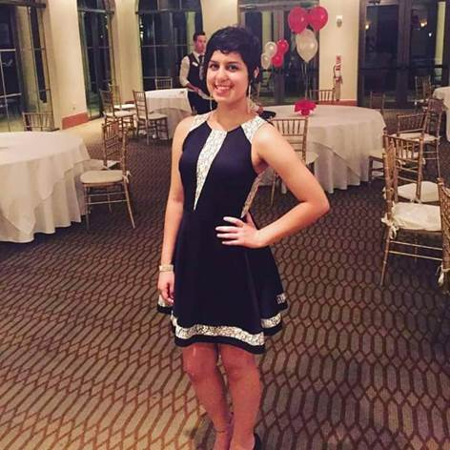

**SARITA- A PROM TO REMEMBER**

<http://woobox.com/zyzn4s>

Sarita Moreno was only 15 years old when diagnosed with ALL (Acute Lymphoblastic Leukemia) on New Year’s Eve 2014. Instead of fireworks on the beach as we had planned, we watched them through the window of her hospital room. Countless days at the hospital, the effects of chemo and other drugs took a toll on her already fragile body, and being isolated from the world for a year, was the most difficult thing to endure. But she is a fighter! Thank God and thanks to her amazing medical team she is in remission and in her way to full recovery. Sarita has 6 more months of treatment and we are confident she will overcome everything and anything!

Sarita is back in school full time. Back to her Honors and AP classes and her Marching Band activities. She is also Drum Major! Her love for music has been great therapy and helped her endure the most difficult times of her life. I admire her persistence and determination. She appreciates and enjoys every little moment. She is sweet, kind, patient, and has a heart of gold. She is my Hero!

Every cancer child deserves to be Jr Captain of this parade, but I am kindly asking everyone to vote for my daughter. Her determination, passion, strength and courage are amazing! She is eloquent and very articulate and can be an excellent advocate to the Childhood Cancer awareness cause.

Many never meet their heroes. I gave birth to mine. Vote Sarita!