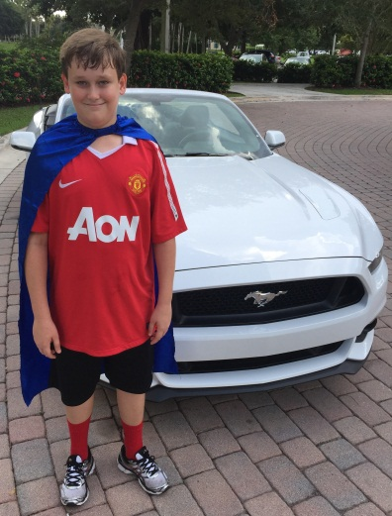
NICK- AUTISM SPEAKS-
http://woobox.com/zyzn4s
Nick is one of the 1 in 68 kids diagnosed with autism, but he’s also 1 in a million. Nick and his parents are very involved in the Autism Speaks chapter in Broward County. Nick was our honored guest at the 2015 Broward Walk, where he led the walk from the backseat of a brand new Ford Mustang convertible. Nick was diagnosed as having autism and auditory processing disorder around the age of 6, and has made remarkable strides over the past 8 years. He loves football, and his parents credit his participation in sports with drawing him out and helping him gain important social skills. He also enjoys video games, and what 14 year old doesn’t. While autism is generally considered to be a lifelong developmental disorder, Nick is determined to fight and win. He wants to see us all move from autism awareness to autism acceptance. He would be absolutely thrilled to be the Junior Captain for the 2016 Winterfest Boat Parade. Please vote.

