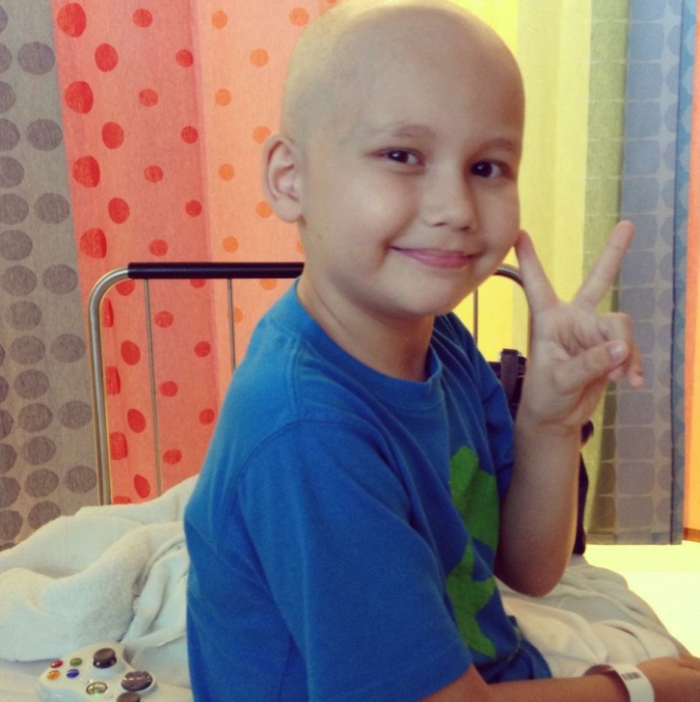

LUCAS- LUCAS RYAN FOUNDATION-

http://woobox.com/zyzn4s

Lucas was diagnosed with high ricks t-cell lymphoma 3 days after his 8th birthday. It was and still is a total shock to us, as no one ever had cancer in our family. His treatment was 3 years..

Through this very long period of time we met all sorts of people, what we all had in common was desperation. We were all desperate, we saw some families having to say good bye to their children, and that was so scary for us all, specially for Lucas who very often would ask me if he's going to die, and if he was to tell him the truth, because he could handle it. I'm crying as I write this, I remember families loosing everything they owned, homes, cars.. People often say yes, but there are charities that do this, unfortunately there aren't many, only about 2 or 3 in the country, and I've often come across, but at ST. Jude, you don't have bills, but what people don't realize is that you have to get to ST. Jude, they don't take everyone, (as they are more of a research hospital) you can only go if your local hospital can't do anything to help you, and the same goes for the Ronald McDonald house, yes they provide room, but there is a really long wait list, and only if the child life specialist puts you on the list because you live very far.

That's how we came up with The Lucas Ryan Foundation. We want to pay for gas, food, rent, car payment, to kind of ease the burden even if it's for just one month. There are so many families in need in South Florida and this was Lucas's goal, to help them, like others helped us. Lucas is very dedicated to making a difference, he finds what happened to him as his reason for helping others. It's so hard to make ends meet when you have to be in the hospital 5 days a week, or 3 months in patient. All the money Lucas and we raise goes to the cause, as non of us take any kind of salary. I wanted to give you a description of Lucas and his vision for his charity. He's a very strong little man. He's not a kid anymore, Lucas is unfortunately an adult stuck in a child's body, he saw and experienced more pain then some of us will in a lifetime. I don't know if he's a hero, although I'm so touched to see Susan speaking like that of my little boy, he certainly is a very kind soul, who love people and wants to make a difference, he loves his doctors and nurses, and has inspired them in so many ways. He's really a ray of light.

Thank you so much for considering him. I'm so honored.
Gratziela Lazarov

