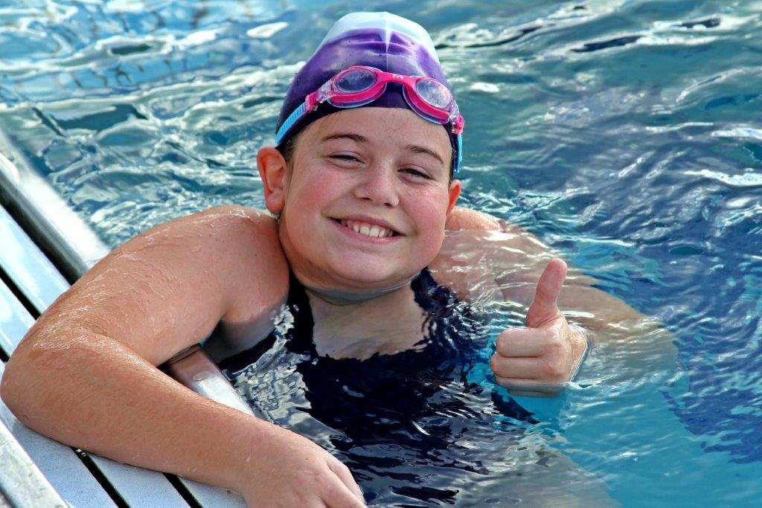

LAYLA- BABY OTTER SCHOLARSHIP AND EDUCATION FUND-

http://woobox.com/zyzn4s

We have a VERY special story about an amazing Autistic child who beat all the odds in her journey to the special olympics. Every swim school turned her parents away stating she wasn't teachable and neither was her autistic brother. We saw it differently and spent countless hours teaching both of these amazing children the life saving skills of swimming. Layla took it to a whole other level and competed in the Special Olympics and place both first and now made it to regionals. Her parents are remarkable people who deal with so much on a daily basis. We nominate layla as the all time hero who never let anyone tell her she can't. We are so proud of her accomplishments and hope you highly consider her as a nominee. This family, especially Layla is so deserving of this. Please make this happen for this family. Two autistic kids, a mother fighting RA, a dad suffering after back surgery, a grandmother with stage 4 breast cancer, yet she still competes and WINS. These are the most deserving people I know of. She is an inspiration in the special needs aquatic world.

