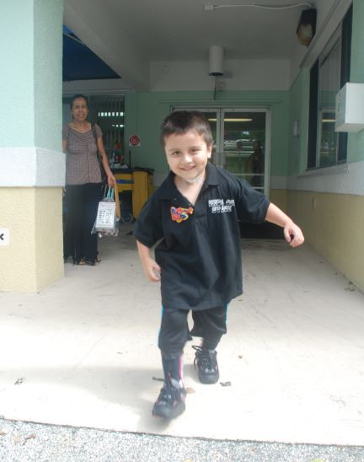

GIOVANNI- BROWARD CHILDREN’S CENTER

Born typical, Giovanni arrived at Broward Children’s Center in November of 2013 after waking up from a coma in the hospital, having survived the trauma of being hit by a car. Giovanni came to the Center in a halo – unable to walk, or talk. He spent 8 months with us here at BCC and went through many aggressive treatments and therapies. In the 8 short months he was here, his halo was removed, he began to talk again, and do typical things, and by the end, Giovanni WALKED, by himself, out of the doors and went back home to his family! Giovanni currently uses our outpatient services for further physical therapy. You can also see his recovery video here: https://www.youtube.com/watch?v=hl-StLGdUeE

