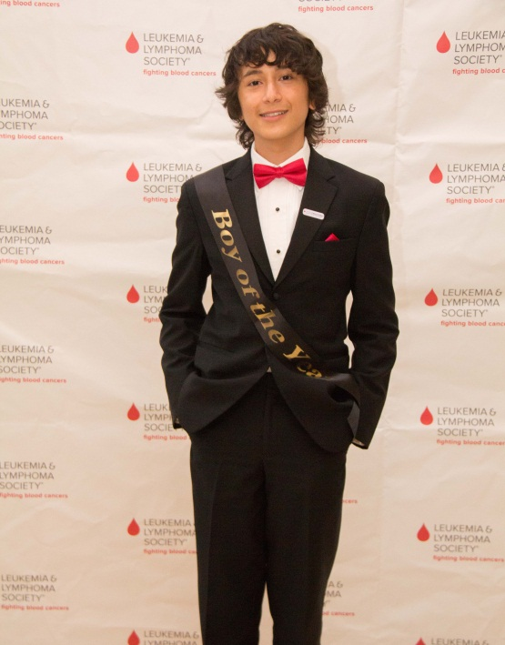

FRANCISCO- LEUKEMIA & LYMPHOMA SOCIETY-

http://woobox.com/zyzn4s

Francisco was diagnosed with Acute Myeloid Leukemia at age 12. It all began when he started experiencing back and joint pain. He was misdiagnosed twice and was treated with no signs of improvement. On March 29, 2012 a biopsy was ordered and the diagnosis was Acute Myeloid Leukemia. Francisco has gone through chemotherapy, blood transfusions, platelets transfusions, never ending antibiotic infusions and taking more than 35 pills a day. Finally, the search for a bone marrow donor came through and the transplant was successful. Determined to speak about his experience, Francisco volunteered with The Leukemia & Lymphoma Society and has helped serve as inspiration for each of our campaigns. He has encouraged others and has been a source of motivation to our many volunteers, patients, and supporters. Francisco says that cancer does one thing: it makes you stronger. He aims to spread awareness and encourage patients to never give up the fight. He hopes that he can help others say that that they are a survivor too!

