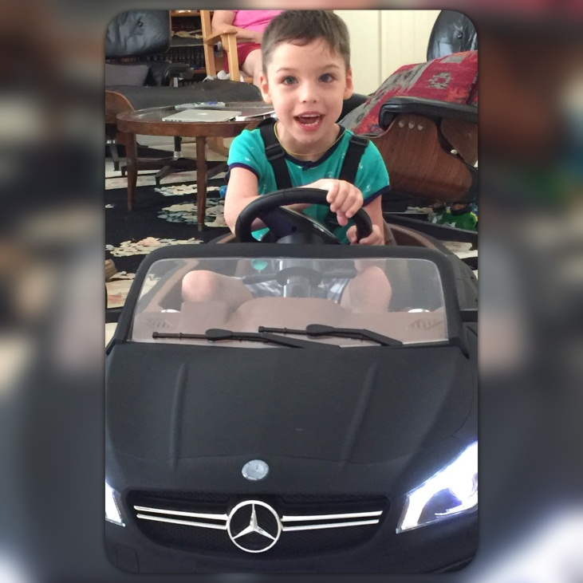

EDDIE- ABI’S PLACE-

http://woobox.com/zyzn4s

Hi! My name is Eddie and I am a twin-less twin! My brother and I were born on January 3, 2010. Sadly, he did not make it. My mom was told I would be a “vegetable.”

At birth, I was diagnosed with Cerebral Palsy and I was blind.

During the first year of life my mom and my grandmother took me home, loved and cared for me beyond anything imaginable. After several operations on my groin muscles I was still unable to sit or stand. That’s when I started physical therapy and my life really changed. I gained stronger back muscles allowing me to sit without help and stand and walk with support. Recently, I started using my left hand. My right hand is working well and I’m starting to draw on a big pad of paper. I’m still non-verbal, so I do a lot of pointing so I can communicate.

Here’s the BEST part! I’m enrolled at Abi’s Place (a school in Coral Springs) where I am with another girl just like me! We are becoming fast friends. I’m learning so much. With all the therapies provided to me, one day I will walk and talk to the best of my ability. And you see my eyes… my gorgeous eyes….? They are seeing you! Oh and yeah… I have a baby sister on the way. She’ll be here soon and I can’t wait!

Ha! Take a look at me now!! I’m happy! I’m healthy! I see!

