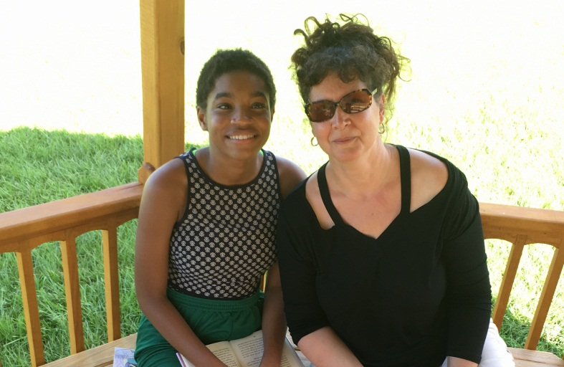

CHANTAL- BIG BROTHERS, BIG SISTERS OF BROWARD COUNTY

Chantal was matched with a Big Sister when she was five years old, just about to turn 6. As part of the Big Brothers, Big Sisters of Broward County, Chantal has participated in many activities and attended many events.
Chantal has faced many obstacles through the years. Last year was a particularly rough year for Chantal. She had to relocate and change schools. In addition, her Father died suddenly. Throughout all the turbulence in her young life, Chantal always remains positive and optimistic. Set backs do not set her back. She is doing well in school. She is considerate and kind. She has a strong spirit. She is a lovely young woman who perseveres. Her strength merits recognition.

